**Unit 3**

**Intro to Chemical Signaling and Communication by Microbes**

1. Differentiate between the general types of cell signals (autocrine, endocrine, etc.) and classes of hormones (polypeptide, amino acid, and steroid)
   * **Intercellular** signaling: communication between cells

* Ligands: molecular that binds another specific molecule, in cell signaling it’s a receptor (a protein) in or on a target cell
  + Example: hormones and neurotransmitters
  + Specificity in cell signaling: each receptor is only able to bind to one very specific ligand, and not all cells have receptors for each ligand
  + **Intracellular** signaling: communication within a cell
  + **Type of cell signaling**:
* Direct signalling: communication between cells in direct contact with each other, mediated by gap junctions and plasmodesmata
* Autocrine: when a ligand acts on the same cell that released it
* Paracrine: when a ligand diffuses in a small area and only acts on neighboring cells
  + Neutral: subset of paracrine signals, diffusing a short distance within the synaptic cleft between adjacent neurons
* Endocrine: hormones, carried throughout the organisms body via the vascular system, to act on cells that may be very far away
  + Neuroendocrine: subcategory of endocrine signals that are released by neurons but that travel via the vascular system to act on cells far away
* Pheromones: released into the environment to act on cells of other individuals

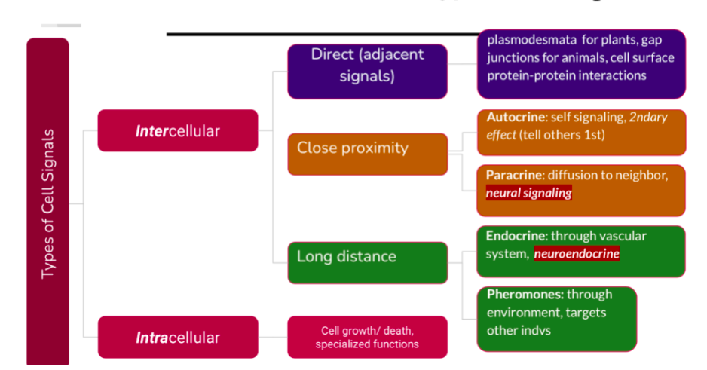

* + **Types of hormones**:
* Hormones regulate functions like homeostasis, development, reproduction, and stress
* Function in cell signaling in all multicellular organisms and single-celled organisms
* Hormones defined by shared functions:
  + is secreted from a cell or gland into the vascular system (or into the environment, in the case of single-celled organisms)
  + acts on distant cells in other locations in the body (or community, in the case of single-celled organisms); this phenomenon occurs because the hormone travels through the circulatory system (or environment)
  + causes large effects even with only small amounts of the molecule; this phenomenon occurs due to *signal amplification*
  + causes a response only in specific target cells even though they come into contact with many different cell types; this phenomenon occurs because only those specific target cells possess a receptor that is capable of binding to that particular hormone
  + causes a characteristic response (always the same response in a given set of circumstances); this phenomenon occurs because activation of the receptor by the hormone initiates a specific *signaling pathway* in response to the hormone
  + is part of a feedback loop (either positive or negative)
* General structural classes of hormones, which dictate how they interact with cell’s receptor:
  + Hydrophilic: hormones that are soluble in water or aqueous solution, so they can’t cross into the cell’s hydrophobic plasma membrane, so the receptor must be on the surface of the cell for the hormone to reach it
    - Tend to include peptide hormones or small proteins
    - Amino acid-derived hormones or modified amino acids
  + Hydrophobic: typical small nonpolar molecules that are insoluble in water, can easily cross the cell’s hydrophobic plasma membrane, so the receptor is found within the cell’s cytoplasm or nucleus
    - Steroid hormones, or small organic compounds with characteristic carbon ring structures
    - 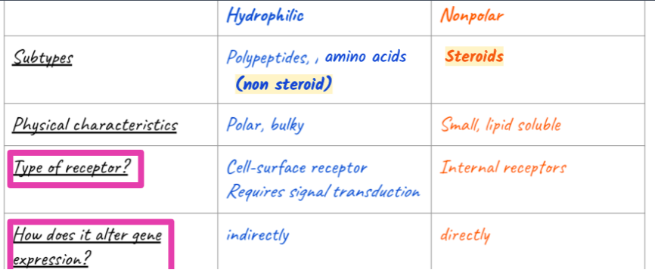Gas hormones or gases capable of acting like

1. Define signal transduction and describe the general pathways of signal transduction and amplification for steroid vs non-steroid hormones
   * Receiving and responding to a hormone signal involves an ordered series of steps:
     1. Signal reception: hormone binding to the receptor (inside the cell or on the cell surface (depending on the hormone)

* Nonpolar , hydrophobic ligands (such as steroid and gas hormones) that are able to travel across the plasma membrane bind to **internal receptors**, also known as intracellular or cytoplasmic receptors, found in the cytoplasm of the cell.
  + Once the hormone binds, the receptor changes shape, allowing the receptor-hormone complex to enter the nucleus (if it wasn’t there already).
  + The hormone-receptor complex is then capable of binding to specific sequences of DNA and activating or repressing transcription of certain genes (the receptor alone can’t do this; it requires the hormone to bind to the DNA).
* Hydrophilic ligands (such as **peptide**and **amino acid-derived** hormones) cannot cross the cell plasma membrane and must bind to **cell-surface receptors**, also known as transmembrane receptors, on the cell surface.
  + Once the hormone binds, the receptor changes shape and activates chemical or protein “messengers” to relay the signal from *outside*the cell to *inside* the cell
  + This signal relay process is called **signal transduction**, which is process of converting a signal from one form to another. In the case of hormone signaling, signal transduction means converting an extracellular signal into an intercellular signal.
  + As a result, the receptor does not alter gene expression directly, but must activate chemical or protein “messengers” to relay the signal from *outside* to *inside*the cell.
    1. Signal transduction: only necessary for hydrophilic ligands that must bind to extracellular receptors cause they cannot cross the plasma membrane
* Once a hormone binds to the extracellular portion of the cell-surface receptor, the intracellular portion of the receptor changes shape, resulting in activation of a chain of events that is called a **signaling pathway** or **signaling cascade**.
* The events in the cascade occur in a defined series of events. Many different enzymes are activated by different specific receptors, but in general this activated enzyme then activates other proteins which carry the signal into the cell to elicit a response.
* Pathways activated by cell surface receptors might include either:
  + synthesis of **second messengers** (non-protein signaling molecules) such as calcium or cyclic AMP which propagate throughout the cell to spread the signal, or
  + initiation of a **phosphorylation cascade** where a series of proteins are activated by having a phosphate group added to them, which changes their activity.
* Ultimately the activation of the pathway results in some type of cellular response, which may include changes in gene expression.

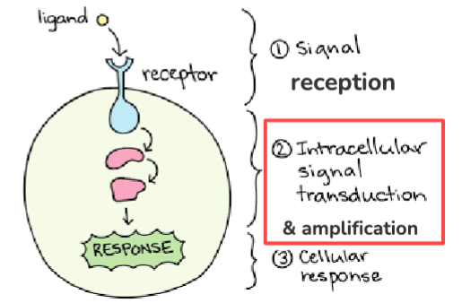

* + 1. Signal amplification: one feature of hormones is that only a very small amount of the hormone can result in a very strong physiological response. This phenomenon is mediated through a process called **signal amplification**, where the signal from the hormone is “amplified” or magnified via one of several mechanisms:
* For hydrophilic hormones that bind to cell-surface receptors, the amplification can occur via second messengers, where thousands of molecules are produced or released in response to the hormone signal, or through or phosphorylation cascades, where thousands of proteins become activated
* For nonpolar hormones that bind to intracellular receptors, the amplification can occur during the process of both transcription, where hundreds of copies of mRNA are synthesized from a single gene, and during translation, where hundreds of copies of each protein are synthesized from a single mRNA

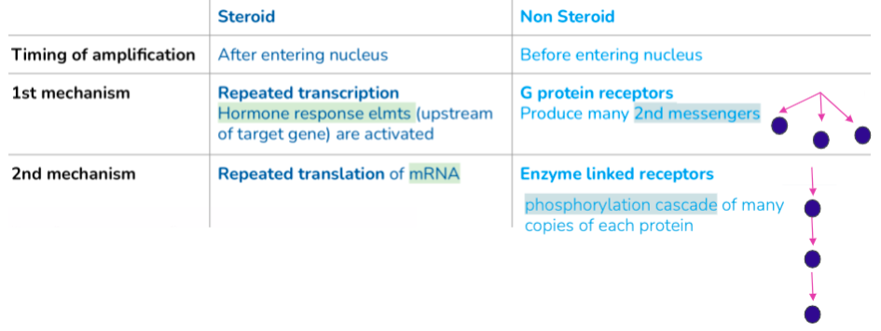

1. Define and differentiate between positive and negative feedback loops in hormonal control
   * Feedback loops: many different types of cellular responses to a hormone, including changes in gene expression, changes in cell metabolism, and/or changes in cell growth and division

* Positive feedback loop: when the response to a hormone causes the original signal to be amplified or increase
* Negative feedback loop: when the response to a hormone causes the original signal to be decreased

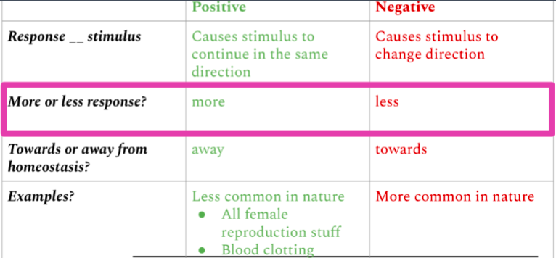

1. Define and recognize crosstalk and other sources of complexity in signaling such as different receptors and/or different signaling pathways in different cell types
   * The same hormone can act on several different cell types, causing a different response in each because the cells themselves carry out different functions and have different intracellular proteins that respond to the hormone.

* For example, the hormone adrenaline causes blood vessels in skeletal muscle to dilate, and it causes liver cells to release glucose into the blood stream. These different responses occur even though both cell types have the same type of receptor to bind to adrenaline.
  + In some cases, the same hormone can cause different responses in different cells due to different *receptors*in the two different cell types, which then activate different signaling pathways and ultimately leading to different responses in each cell type.
* For example, adrenaline causes blood vessels in skeletal muscle to dilate, but it causes blood vessels in the intestine to constrict. These different responses occur because blood vessels in skeletal muscle have a different type of adrenaline receptor compared to blood vessels in the intestines.
  + Often multiple signaling pathways interact with each other because the same signaling proteins are involved in multiple pathways. As a result, if signals from two different hormones are received at the same time, the outcome can be different than if they came in separately. The phenomenon where the outcome can change based on interactions between different signaling pathways is called **signaling crosstalk.**
* For example, when blood glucose levels are high, the hormone insulin causes muscle cells to take up the excess glucose to remove it from the blood. However, when adrenaline is also present, the adrenaline signaling pathway in muscle cells blocks the insulin signaling pathway, meaning that the muscle cells do not take up excess glucose when adrenaline is present, even when insulin is also present.

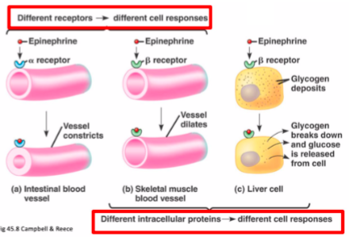

1. Define quorum sensing and describe the role of cell signaling microbe behaviors
   * **Quorum sensing**: a phenomenon where individual cells monitor the density of their population, once the population reaches a specific density, the cells collectively change their gene expression and behavior at the same time

* Behaviors regulated by quorum sensing:
  + Formation of biofilms
  + Attacking competitors
  + Luminescence (emitting light)
  + Activation of virulence genes (associated with pathogenicity, or the ability to cause an infection)
* Quorum sensing is based on a bacterial hormone called autoinducer, which is a signaling molecule that is continuously secreted
* Production rate of autoinducer is constant but concentration goes up as cells reproduce
* The more cells secreting it the greater the density of the hormone, which then causes a cellular response in all cells at the same time, the cells collectively changing their behavior based on whatever signaling pathway activated by the hormone
* Each specific has its own autoinducer with a specific receptor that won’t be activated by another species autoinducer
  + Symbiosis and bioluminescence: Quorum sensing was first discovered in *Aliivibrio fischeri*, a bacterium that has a symbiotic (mutually beneficial) relationship with the Hawaiian bobtail squid. *A. fischeri* form colonies inside the squid’s “light organ.” The squid gives the bacteria food, and in return, the bacteria bioluminesce (emit light). The glow of the bacteria prevents the squid from casting a shadow, hiding it from predators swimming beneath.
* *A. fischeri* bacteria only glow when they are inside of a squid’s light organ; they don’t glow when they are free-living in the ocean. Through decades of work, scientists discovered that the bacteria use quorum sensing to decide when to produce bioluminescence. It would be a metabolic waste for a lone bacterium in the open ocean to carry out chemical reactions that emit light, since they provide no benefit without a squid host. But when many bacteria are tightly packed in a light organ, the action of glowing in unison provides an advantage: it allows the bacteria to fulfill their end of the symbiotic bargain, keeping their squid host (their food source) from being eaten by predators.
* The autoinducer that controls *A. fischeri*‘s behavior activates transcription of genes that encode enzymes and substrates required for bioluminescence, as well as the gene for the enzyme that makes the autoinducer itself (amplifying the response in a **positive feedback loop**).
  + Biofilm formation: Some species of quorum-sensing bacteria form biofilms, which are communities of bacterial cells that stick to one another and to a surface. Biofilms can be quite complex, with bacterial cells organizing to form ordered structures, and some biofilms contain multiple species of coexisting bacteria.
* Biofilms are present almost everywhere: they produce dental plaque (if you haven’t brushed your teeth recently, you might feel the start of a biofilm colonizing your teeth), and they colonize catheters, prostheses, transcutaneous and orthopedic devices, contact lenses, and internal devices such as pacemakers. It is estimated that 65 percent of all infections acquired in the hospital are due to biofilms. Biofilms are also related to diseases contracted from food because they colonize the surfaces of vegetable leaves and meat, as well as food-processing equipment that isn’t adequately cleaned.
* Biofilms are more robust and resilient than free-living bacteria. The sticky substance that holds the bacteria together also excludes most antibiotics and disinfectants, so it’s harder to kill the cells in a biofilm. In addition, individual cells within a biofilm actually take on specialized roles, similar to multicellular organisms, with some cells forming channels to help remove toxins (such as antibiotics) from the biofilm.
* Once an infection by a biofilm is established, it is very difficult to eradicate, because biofilms tend to be resistant to most of the methods used to control microbial growth, including antibiotics and detergents. Biofilms respond poorly or only temporarily to antibiotics; it has been said that they can resist up to 1,000 times the antibiotic concentrations used to kill the same bacteria when they are free-living. An antibiotic dose that large would harm the patient; therefore, scientists are working on new ways to get rid of biofilms.
  + Virulence: Virulence, or the ability of a microorganism to cause disease, is also controlled by quorum sensing. As one example, the opportunistic pathogen [*Pseudomonas aeruginosa*](https://en.wikipedia.org/wiki/Pseudomonas_aeruginosa) uses quorum sensing to coordinate the formation an array of behaviors including virulence.
* These bacteria can grow within a host without harming it, until they reach a threshold concentration. Once they have replicated to the point at which their numbers are sufficient to overcome the host’s immune system, quorum sensing induces expression of virulence genes, causing the bacteria to become aggressively infectious and also a biofilm.
* This change in bacterial behavior not only leads to infection and disease within the host, but also prevents the host’s immune system from combating the bacteria as the biofilm provides a protective layer encasing the bacteria population away from the immune cells.
* This type of infection is particularly common in the lungs of patients with cystic fibrosis, and is extremely difficult to treat. Quorum sensing-mediated virulence pathways play a role in infection caused by many other species of bacteria, which infect both animals and plants.

**Animal Hormones**

1. Identify the major glands and body structures involved in hormone synthesis in vertebrates, including the hypothalamus, the pituitary, the thyroid, and the adrenal glands and Recall the functions of selected hormones produced by select major glands, including the hypothalamus, the pituitary, the thyroid, and the adrenal glands
   * **Hypothalamus**: located within the brain, the hypothalamus integrates the endocrine and nervous systems; it receives input from the body and other brain areas and initiates endocrine responses to environmental changes, synthesizes hormones which are stored in the posterior pituitary gland, and also synthesizes and secretes regulatory hormones that control the endocrine cells in the anterior pituitary gland
   * **Pituitary gland**: the body’s “master gland,” located at the base of the brain and attached to (and regulated by) the hypothalamus

* Anterior portion: the pituitary gland is regulated by releasing or release-inhibiting hormones produced by the hypothalamus
* Posterior pituitary: receives signals via neurosecretory cells to release hormones produced by the hypothalamus
  + **Thyroid gland**: butterfly-shaped gland located in the neck; regulated by the hypothalamus-pituitary axis; produces hormones involved in regulating metabolism and growth including **thyroxine (T4)**and **triiodothyronine (T3)** which increase the basal metabolic rate, affect protein synthesis and other metabolic processes, help regulate long bone growth (synergy with growth hormone)
  + **Adrenal glands**: two glands, each located on one kidney; consist of adrenal cortex (outer layer) and adrenal medulla (inner layer), which each produce different sets of hormones:
* the **adrenal cortex** produces **mineralocorticoids,**such as**aldosterone**, which increases reabsorption of sodium by kidneys to regulate water balance; and **glucocorticoids,**such as**cortisol**, which is a long-term stress response hormones that increase blood glucose levels by stimulating synthesis of glucose and gluconeogenesis (converting a non-carbohydrate to glucose) by liver cells; promote the release of fatty acids from adipose tissue
* the **adrenal medulla** produces **epinephrine (adrenaline)**a short-term stress response (“fight-or-flight”) hormone that increases heart rate, breathing rate, cardiac muscle contractions, blood pressure, and blood glucose levels; accelerates the breakdown of glucose in skeletal muscles and stored fats in adipose tissue; the release of epinephrine is stimulated directly by neural impulses from the sympathetic nervous system
  + **Pancreas**: located between the stomach and the proximal portion of the small intestine; regulates blood glucose levels via two opposing hormones: **insulin**, which decreases blood glucose levels by promoting uptake of glucose by liver and muscle cells and conversion to glycogen (a sugar storage molecule) and **glucagon**, which increases blood glucose levels by promoting breakdown of glycogen and release of glucose from the liver and muscle
  + 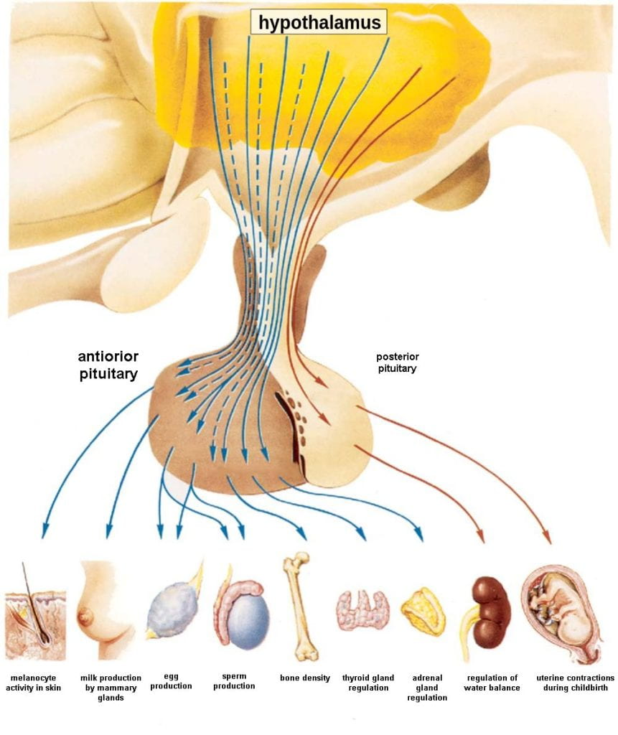**Gonads** (ovaries and testes): produce sex steroid hormones that promote development of secondary sex characteristics and regulation of gonad function

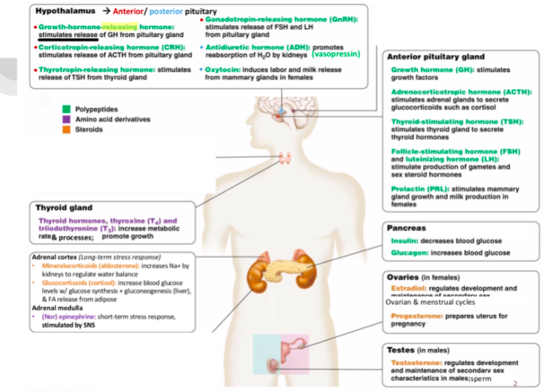

1. Describe the hormone pathway in given examples, including blood glucose, metamorphosis, and stress; and make predictions on how an animal would respond to given stimuli for each case
   * Blood glucose:

* Insulin: produced by beta cells of the pancreas, which release insulin when blood glucose levels rise above normal levels
  + Process:
    - Enhances the rate of glucose uptake and utilization by target cells which use glucose for ATP production
    - stimulates the liver to convert glucose to glycogen, which is then stored by cells for later use
    - increases glucose transport into certain cells, such as muscle cells and the liver
    - stimulates the conversion of glucose to fat in adipocytes and the synthesis of proteins.
  + Negative feedback loop: These actions together cause cause blood glucose concentrations to fall, called a *hypo*glycemic ‘low sugar’ effect, which inhibits further insulin release from beta cells
* Glucagon: When blood glucose levels decline *below* normal levels, released from the alpha cells of the pancreas. Glucagon raises blood glucose levels, causing a *hype*rglycemic effect through several mechanisms:
  + Process:
    - stimulates the breakdown and release of glucose from glycogen in liver cells
    - stimulates absorption of amino acids from the blood by the liver, which then converts them to glucose
    - stimulates adipose cells to release fatty acids into the blood
  + Negative feedback mechanism: Glucose can then be utilized as energy by muscle cells and released into circulation by the liver cells. These actions mediated by glucagon result in an increase in blood glucose levels to normal homeostatic levels. Rising blood glucose levels 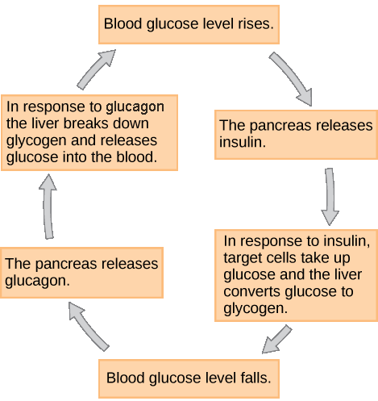inhibit further glucagon release by the pancreas
  + Metamorphosis: The thyroid gland in vertebrates controls growth and metabolism through the hormones **thyroxine (T4)**and **triiodothyronine (T3)**; in vertebrate species like amphibians that undergo metamorphosis, surges of T3 are initiate the development of new structures, reorganize internal organ systems, and control other processes that occur during metamorphosis.
* The corpus allatum, an endocrine gland in the brain, secretes a hormone called **juvenile** **hormone**during all larval stages, which maintains the larval status of the animal.
* As the larvae grows, another endocrine gland in the brain releases **prothoracicotropic hormone**, which signals to the prothoracic gland to release the hormone **ecdysone**.
* Ecdysone promotes either molting (shedding the exoskeleton) or metamorphosis, depending on the level of juvenile hormone.
* Ecdysone in combination with high juvenile hormone results in molting into the next larval stage; ecdysone in combination with low juvenile hormone results in metamorphosis into an adult. (Notice the difference in outcome in response to ecdysone based on whether juvenile hormone is present; this phenomenon is an example of **crosstalk**.)
  + Stress: stimuli that disrupt homeostasis Some stressors require immediate attention and activate the short term, “fight-or-flight” stress response, which stimulates an increase in energy levels through increased blood glucose levels.
* Long term stress: body has evolved a response to counter long-term stress through the actions of the glucocorticoids, which ensure that long-term energy requirements can be met. The glucocorticoids mobilize lipid and protein reserves, stimulate gluconeogenesis, conserve glucose for use by neural tissue, and stimulate the conservation of salts and water.
* Short term stress: glycogen reserves
* The sympathetic nervous system regulates the stress response via the **hypothalamus**. Stressful stimuli cause the hypothalamus to signal the **adrenal medulla** (which mediates short-term stress responses) via nerve impulses, and the **adrenal** **cortex**, which mediates long-term stress responses, via the hormone adrenocorticotropic hormone (ACTH), which is produced by the **anterior pituitary**.
* Short term stress response:
  + When there is a stressful situation the body responds by calling for the release of hormones to provide a burst of energy
  + Epinephrine (adrenaline) and norepinephrine (noradrenaline) are released by the adrenal medulla
  + The hormones work by:
    - cause glycogen to be broken down into glucose and released from liver and muscle cells
    - increase blood pressure
    - increase breathing rate
    - increase metabolic rate
    - change blood flow patterns, leading to increased blood flow to skeletal muscles, heart, and brain; and decreased blood flow to digestive system, skin, and kidneys
* Long term stress response: the body cannot sustain the bursts of energy mediated by the epinephrine and norepinephrine for long times
  + the hypothalamus triggers the release of ACTH from the anterior pituitary gland. The adrenal cortex is stimulated by ACTH to release steroid hormones called **corticosteroids** (under a negative feedback loop)**.** The two main corticosteroids are **glucocorticoids** such as cortisol, and **mineralocorticoids** such as aldosterone.
  + These hormones mediate the long-term stress response in the following ways:
    - glucocorticoids:
      * promote breakdown of fat into fatty acids in the adipose tissue and release into bloodstream for ATP production
      * stimulate glucose synthesis from fats and proteins to increase blood glucose levels
      * inhibit immune function to conserve energy
    - mineralocorticoids:
      * promote retention of sodium ions and water by kidneys
      * 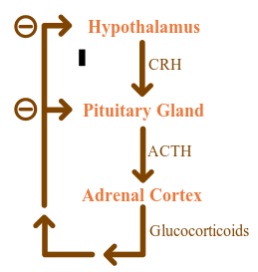increase blood pressure and volume (via sodium/water retention)

1. Recognize instances of negative feedback lo ops, positive feedback loops, and crosstalk in the example hormone pathways

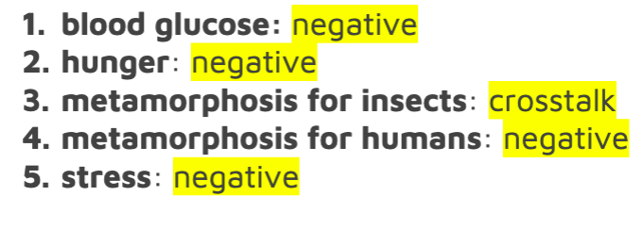

**Plant Hormones and Sensory Systems**

1. Identify the hormones that regulate specific plant behaviors and describe their role in that behavior, including auxin, cytokinin, gibberellin, abscisic acid, and ethylene
   * **Auxin**: the ‘youth’ hormone and the master growth regulator

* Tissues with high levels of auxins tend to behave as ‘younger’ tissues: they are areas of new growth and they don’t exhibit signs of aging (senescence).
* Auxins are the main hormones responsible for cell elongation in **phototropism** (movement in response to light) and **gravitropism** (movement in response to gravity), **apical dominance** (inhibition of lateral bud formation), and **inhibition of abscission** (leaf falling) are other plant responses under the direct or indirect control of auxins.
* Synthetic auxin is used as a rooting hormone to promote growth of roots on cuttings and detached leaves.
  + **Cytokinin**: cell division hormone
* Cytokinin promotes **cytokinesis** (cell division). Cytokinins are most abundant in growing tissues, such as roots, embryos, and fruits, where cell division is occurring.
* The effects of cytokinins are often also influence by auxin; for example, **apical dominance** seems to result from a balance between auxins that inhibit lateral buds, and cytokinins that promote bushier growth.
  + **Gibberellin**: growth hormone (stem, fruit, seed growth)
* Gibberellins (GAs) stimulate **shoot elongation**, **seed germination**, and **fruit**and **flower** **maturation**; GAs are synthesized in the root and stem apical meristems, young leaves, and seed embryos.
* GAs also break **dormancy** (a state of inhibited growth and development) in the seeds of plants that require exposure to cold or light to germinate.
* Maturing grapes are routinely treated with GA to promote larger fruit size.
  + **Abscisic Acid (ABA)**: dormancy hormone
* ABA accumulates as a response to stressful environmental conditions, such as dehydration, cold temperatures, or shortened day lengths. Its activity counteracts many of the growth-promoting effects of GAs and auxins.
* ABA causes the **abscission** (dropping) of leaves, **inhibits stem elongation**, induces **dormancy** in **lateral buds** and **seeds**, and **closes stomata** in short-term drought conditions.
  + **Ethylene**: aging hormone (leaf abscission and fruit ripening)
* Ethylene is unusual as a hormone because it is a volatile gas (C2H4).
* Ethylene promotes **fruit** **ripening**, **flower** **wilting**, and **leaf** **abscission** (falling)
* Aging tissues (especially older leaves) and nodes of stems produce ethylene,
* Ethylene is widely used in agriculture. Commercial fruit growers control the timing of fruit ripening with application of the gas. Horticulturalists inhibit leaf dropping in ornamental plants by removing ethylene from greenhouses using fans and ventilation.

1. Recognize the stimulus (blue light, red light, far-red light, gravity, water, water stress, touch) that provokes a specific plant behavior, including phototropism, gravitropism, germination, stomatal closing, and thigmotropism and Describe the pathways that regulate specific plant behaviors, including phototropism, gravitropism, germination, and water stress
   * Blue Light:

* Plants can respond to at least 3 different wavelengths of light (blue light, red light, and far red light)
* The wavelengths are detected by photoreceptors (chromoprotein) made up of a protein bonded to a light absorbing pigment (chromophore)
* Behaviors regulated by light:
  + Phototropism (movement toward light)
  + Stem elongation (growth)
  + Germination (seed sprouting)
  + Photoperiodism (flowering in response to length of day)
* **Phototropism:** movement toward or away from light
  + Phototropins: chromoproteins (proteins containing pigmented co-factors) which are responsible for mediating the phototropic response and also control opening of stomata to permit gas exchange
  + Light is detected by the tip of the stem (apical meristem) and the response or bending of the stem happens at the base of the stem as a result of signals from the apical meristem
    - Detection of light in apical meristems happens via phototropins called phot1 and phot2
    - In 1913, Peter Boysen-Jensen cut off the tip of a seedling, covered the cut section with a layer of gelatin (essentially Jell-O), and then replaced the tip. The cut seedling could still bend toward the light. But when he inserted an impermeable barrier (instead of Jell-O) between the tip and the cut base, the seedling could no longer bend in response to light. Later experiments showed that the signal traveled on the *shaded* side of the seedling: when the barrier was inserted only on the illuminated side, the plant could still bend towards the light. Therefore, the chemical signal was a growth stimulant because the phototropic response involved great cell *elongation*on the shaded side than on the illuminated side, which resulted in the stem bending toward the light. We now know that the chemical signal is the plant hormone **auxin**. (Auxin also controls many other plant behaviors not described here.)
    - Acid growth hypothesis: auxin stimulated cell elongation on the shady side of the stem by causing cells to activate proton pumps, which then pump protons out of the cells and into the space between the plasma membrane and the cell wall. This does two things
      * Lower pH activates expansin, which breaks the links between the cellulose fibers in the cell walls, making them more flexible
      * The high concentration of protons causes sugars to move into the cell, which ten creates an osmotic gradient where water moves into cell causing the cell to expand
    - The phototropic response works:
      * the phototropins phot1 and phot2 are present in the plant apical meristem
      * when activated by blue light, phot1 and phot2 cause accumulation of auxin on the shaded side of the plant.
      * auxin promotes cell elongation due to weakening of the cell wall combined with influx of water (which literally stretches the cells)
      * 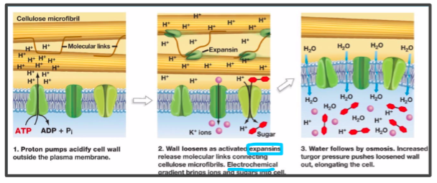because the cell expansion occurs only on the shaded side of the stem, the plant bends away from the shade and toward the light
  + Red light: promotes stem elongation or growth
* Plants use red vs far red light to grow away from the shade toward the light: Red light indicates full sun to a plant, while far-red light indicates that a plant is being shaded out by another plant. This is because unfiltered, full sunlight contains much more red light than far-red light.
* Chromoprotein responsible for red/far-red light detection is phytochrome, which is like a reversible switch that can absorb either red light or far red light
* Phytochrome has two photo-interconvertible forms, named for the wavelength of light they are capable of absorbing:
  + Pr (phytochrome red) is capable of absorbing red light (667 nm)
  + Pfr (phytochrome far-red) is capable of absorbing far-red light (730 nm)
  + When the Pr form absorbs red light, it is immediately converted to Pfr; and when Pfr absorbs far-red light, it is quickly converted back to Pr.
  + Pfr is the physiologically active form of the protein. Because phytochrome is in the Pfr state *after* exposure to red light, this means that exposure to red light turns the phytochrome “on.”
  + Exposure to far-red light inhibits phytochrome activity

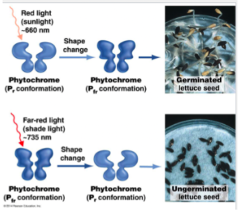

* Behaviors that phytochrome system regulates:
  + Phytochrome stimulates plant **growth** toward red light in combination with the hormones **cytokinin**, which promotes cell division, and **gibberellin**, which promotes stem elongation. (Interestingly, cytokinin is only capable of promoting cell division when it is also in the presence of **auxin**, which is present at apical meristems but not other locations in the plant. Auxin also regulates levels of gibberellin.)
  + The phytochrome system also regulates seed **germination** in many plant species (illustrated below). As we’ve [previously discussed](https://organismalbio.biosci.gatech.edu/growth-and-reproduction/plant-reproduction/), the seeds of many plants go into a dormant state after fertilization, in part to ensure that the seed germinates at a time and in a place that the seedling is more likely to successfully survive. There are many different signals that can trigger seed germination, depending on the plant species. For many plant species, this signal is red light, as red light provides a signal that the seed is in a good location for access to sunlight after germination. In contrast, a seed that germinates in shaded areas, or too deep under the soil to reach the sunlight, is likely to die soon after germination. In the dark, phytochrome is in the Pr (inactive form) and the seed will not germinate; it will only germinate if exposed to light at the surface of the soil. Upon exposure to light, Pr is converted to Pfr, Pfr signaling causes transcription of the gene that encodes **amylase**, an enzyme that breaks down starches stored in the seed into simple sugars, and then germination proceeds. (Note that some species of plants initiate germination through an light-independent process regulated by the hormone **gibberellin**, which is further described below.)
  + Gravity (gravitropism): ensures that the roots grow into the soil and that shoots grow toward sunlight
* Growth downwards of the roots is called positive gravitropism
* Growth upwards of the shoot apical tip is negative gravitropism
* Amyloplasts (also known as statoliths) are specialized cellular compartments that contain starch granules that move in response to gravity
  + The starch granules are heavy, and they literally fall to the bottom of the cell in response to gravity. Amyloplasts are found in shoots and in specialized cells of the root cap. When a plant is tilted, the statoliths drop to the ‘new’ bottom cell wall, which causes **auxin**(produced by the root apical meristem just like at the shoot apical meristem) to redistribute to the new bottom of the root. In roots, a high concentration of auxin *inhibits* cell elongation, slowing growth on the lower side of the root, while cells develop normally on the upper side and causing the root to bend *toward* the high concentration of auxin and thus causing the root to grown down. Note that this is the ***exact opposite* of auxin’s affect on shoots**, where a higher concentration stimulates cell expansion, causing the shoot to bend *away* from the higher concentration of auxin. After root begins to grow vertically again, the amyloplasts return to their normal position and auxin is equally distributed on both sides of 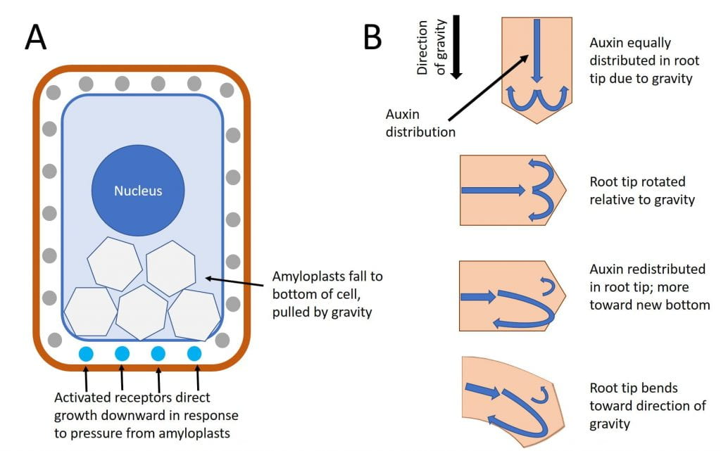the root tip.
  + Growth responses: plant responses to different growth-related stimuli
* **Apical dominance**: many plants grow primarily at a single apical meristem and have limited lateral branches (which would result in multiple meristems). This phenomenon is called **apical dominance**, and is regulated by the presence of **auxin** at the apical meristem. Auxin is required for the function of other growth-regulating hormones such as **cytokinins**; cytokinins promote cell division, but only in the presence of auxin. Abscisic acid in the lateral buds inhibits production of auxin, and removal of the apical bud will release this inhibition of auxin, allowing the lateral buds to begin growing.
* **Leaf abscission**: some plants drop leaves in response to changing seasons (based on temperatures, photoperiod, water, or other environmental conditions). This process is called **leaf abscission**, and is regulated by interactions between **auxin** and **ethylene**. During the growing season, the leaf produces high levels of auxin which blocks activity of ethylene; however, as the seasons change, the leaf produces lower levels of auxin. Lower levels of auxin permit ethylene to initiate senescence (aging) and ultimately programmed cell death at the site of leaf attachment to the stem, allowing the leaf to fall off in a controlled manner without harming the rest of the plant.
* **Fruit growth**: growth of fruits in size is promoted by **gibberellins**. Artificial addition of gibberellins to fruits while still on the plant will cause them to grow larger than they ordinarily would.
* **Fruit ripening**: once fruits have grown to the appropriate size, they begin ripening; this process is stimulated by **ethylene**. Fruit ripening is a form of senescence (aging), so the role that ethylene plays in fruit ripening is very similar to its role in leaf abscission.
  + **Response to water or water stress (drought)**:
* **Germination** : though we previously discussed germination controlled by the phytochrome system, the seeds of some plant species instead rely on the imbibition (intake) of **water** to initiate germination (shown below).  Intake of water activates the hormone **gibberellin**, which then signals to transcribe the gene encoding **amylase**, an enzyme that breaks down starches stored in the seed into simple sugars, and then germination proceeds (note these final steps are identical to what occurs in phytochrome-regulated germination). When water is absent, germination in this pathway is blocked by a hormone called **abscisic acid**(also called **ABA)**, which inhibits the activity of gibberellins. Thus gibberellins and abscisic acid act in opposition in regulating the the germination response.
* 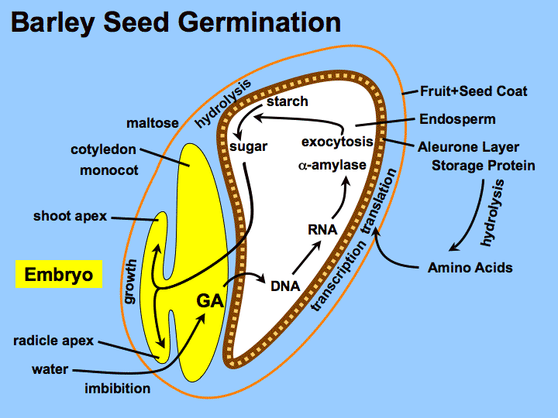**Stomatal closing**: as briefly noted above, activation of **phot1**and **phot2**by blue light cause stomata to open to permit gas exchange so that photosynthesis can occur. But in addition to sunlight and carbon dioxide, photosynthesis also requires water. When the plant is dehydrated due to drought, the hormone **abscisic acid** (ABA) causes stomata to close, preventing gas exchange and halting photosynthesis. This response to abscisic acid occurs *even if blue light is present*(Signaling from drought via ABA overrides the signaling from blue light via phot1).

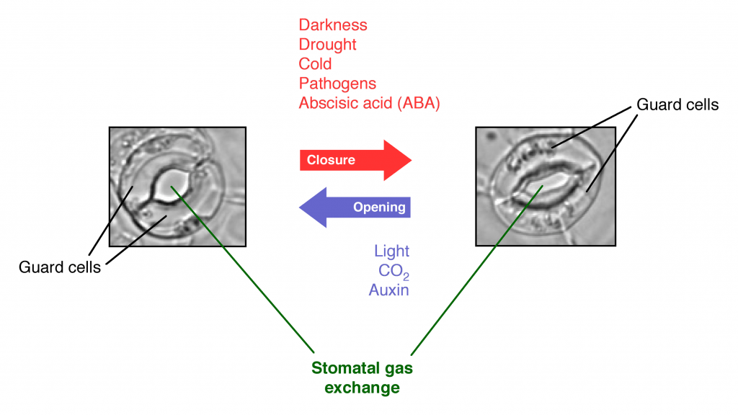

* **Local cell death:** in drought conditions, the immediate response is closing stomata, as noted above. However, because closed stomata prevent gas exchange, plants will die if the stomata remain closed for too long. Thus if a drought persists for too long, the plant will begin sacrificing certain areas by allowing the leaves or stems to die in localized regions. This process may be regulated by the hormone **ethylene**, which can induce localized cell death under certain conditions.
  + **Responses to touch (Thigmotropism):** movement in response to touch, there is slow and fast thigmotropism
* Slow thigmotropism: regulated by auxin and describes a plant response to touch stimulus that affects direction of growth, such as vines that wrap around or grow along structures
  + Auxin redistributes in the elongating stem in reponse to touch ultimately resulting in different cell elongation
* Fast thigmotropism: rapid plant response to touch (venus fly trap), is a result of an electrical signal which causes rapid changes in cell turgor pressure and thus rapid movement of structures associated with those cells

1. Interpret and predict outcomes of experiments manipulating plant signaling pathways

**Neurons**

1. Describe the structure and function neurons
   * Neurons: specialized cells that can receive and transmit chemical or electrical signals, and they are supported by cells called glia, which provide support functions for the neurons
   * Neurons communicate via both electrical signals an chemical signals:

* Electrical signals are action potentials which transmit the information from one of a neuron to the other, a rapid, temporary change in membrane potential (electrical charge), caused by sodium rushing to a neuron and potassium rushing out
* The chemical signals are **neurotransmitters**, which transmit the information from one neuron to the next. Neurotransmitters are chemical messengers which are released from one neuron as a result of an action potential; they cause a rapid, temporary change in the membrane potential of the adjacent neuron to initiate an action potential in that neuron.
  + Neuron structure:
* Soma (cell body): contains nucleus and other cellular organelles and components
* Dendrites: structure where neurons receive signals from other neurons, are tree like structures that extend away from the cell body to receive neurotransmitters from other neurons. Some types of neurons do not have any dendrites, some types of neurons have multiple dendrites. Dendrites can have small protrusions called dendritic spines, which further increase surface area for possible connections with other neurons.
* Axon: where a neuron will transmit an action potential to ultimately reach the next neuron, tube like structure that propagates the integrated signal to specialized endings called axon terminals (usually have one or two axons)
  + Some are covered in myelin (a type of insulator) that minimizes dissipation of the electrical signal as it travels down the axon, it increases the speed of conduction
  + Gaps in the myelin sheath called nodes of Ranvier where the signal is re-charged as it travels down the axon
  + The myelin sheath is produced by glial cells
* Synapses: location where two neurons are almost in contact with each other and where a signal is transmitted from one neuron to the next. One side of the synapse is the pre-synaptic neuron (neuron sending the signal), axon terminal. Other side is dendrite or dendritic spine of the post-synaptic neuron (neuron receiving signal)
  + There is a synaptic cleft, a gap where neurotransmitters are released from one neuron to pass the signal to the next neuron
* Axon hillock: where action potential initiates within a neuron, site that effectively controls whether or not an action potential will occur, where conflicting signals are integrated. Located between the neuron cell body and the start of the axon. Integration will determine whether the neuron will initiate an action potential

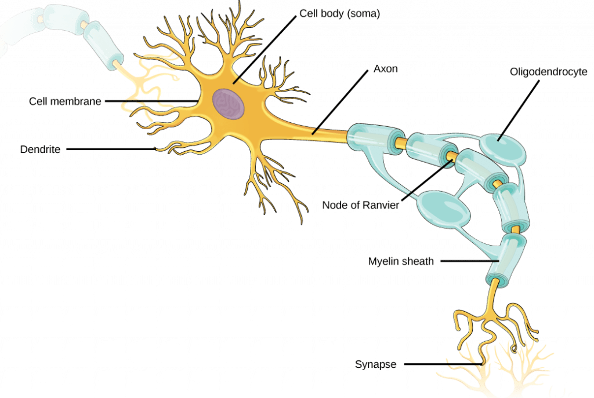

1. Explain the role of membrane potential in neuron communication
   * Membrane potential allows for the transmission of a signal within a neuron (from dendrite to axon terminal)
   * Each neuron has a charged cellular membrane, a brief change in membrane potential (membrane electrical charge) called an action potential
   * The charge of the membrane can change in response to neurotransmitter molecules released from other neurons and environmental stimuli
   * **Resting potential**: the membrane potential (electrical charge) in a neuron that is *not* currently transmitting a signal; maintained by the sodium potassium pump and potassium leak channels
   * **Action potential**: a brief depolarization (reduction in magnitude of the charge) along the neuron’s axon; action potentials are all-or-nothing (they do not have degrees of magnitude); regulated by voltage-gated sodium channels, voltage-gated potassium channels, and the sodium potassium pump
   * **Neurotransmitters**: the chemical messengers that communicate between adjacent neurons; release of neurotransmitters from one neuron will either help depolarize or hyperpolarize (increase the magnitude of the charge) the adjacent neuron, making an action potential either more or less likely to occur in the next neuron
2. Identify and differentiate between the different types of ion channels that regulate neuron function
   * Sodium-Potassium pumps and potassium leak channels (resting potential):

* Cells can use energy to preferentially move certain ions either inside or outside of the membrane, setting up a difference in ion charge across the membrane, where one side is relatively more negative, and the other side is relatively more positive. The difference in total charge between the inside and outside of the cell is called the **membrane potential**.
* Membrane potential at rest is negatively charged
* Voltage is called the resting membrane potential, caused by difference in the concentrations of ions inside and outside the cell
* Resting potential is established and maintained by two main processes: ATP powered ion channel (sodium-potassium pump) and a passive ion channel (potassium leak channel)
* **Sodium-potassium pump**: which is also called Na+/K+ ATPase, transports sodium out of a cell while moving potassium into the cell. The Na+/K+ pump is an important ion pump found in the membranes of many types of cells. These pumps are particularly abundant in nerve cells, which are constantly pumping out sodium ions and pulling in potassium ions to maintain an electrical gradient across their cell membranes. An electrical gradient is a difference in electrical charge across a space. In the case of nerve cells, for example, the electrical gradient exists between the inside and outside of the cell, with the inside being negatively-charged (at around -70 mV) relative to the outside. The negative electrical gradient is maintained because each Na+/K+ pump moves three Na+ ions out of the cell and two K+ ions into the cell for each ATP molecule that is used. This process is so important for nerve cells that it accounts for the majority of their ATP usage.
* **Potassium leak channels**: allow the potassium to diffuse down its concentration gradient and leak out of the cell. (Neurons also have sodium leak channels, but they have far more potassium leak channels than sodium leak channels, so will focus on potassium leak channels for the purposes of this course).As a result of the positively charged potassium ions leaving the cell, the interior of the cell is negatively charged relative to the outside of the cell.
* 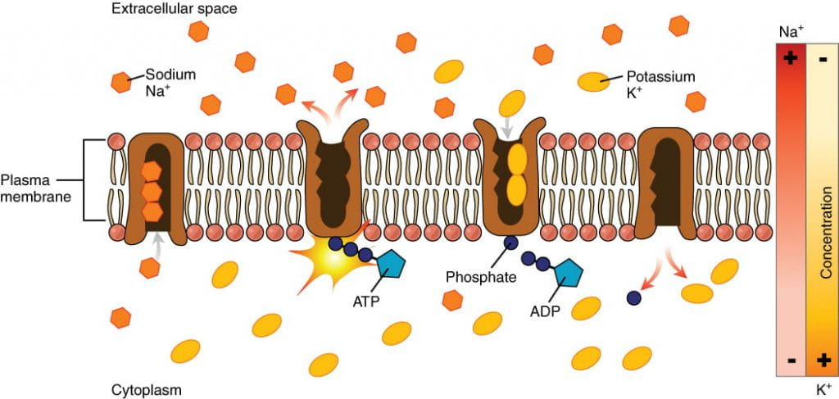These ion channels make the interior more negative than the exterior
  + Voltage-gated sodium channels, voltage-gated potassium channels, sodium potassium pump (action potential)
* Action potential: brief, positive change in the membrane potential along a neuron’s axon, when neurons are firing or being active
* The neuron sends the signal to the next neuron in the communication chain
* What causes an action potential is a signal from another neuron (in the form of neurotransmitters), causing a change in the membrane voltage
* Opening of voltage-gated ion channels may cause the membrane to undergo either a hyperpolarization (the membrane potential increases in magnitude/more negative) or depolarization (the membrane potential decreases in magnitude/more positive)
* Signal must cause a depolarization that is large enough to overcome the threshold potential (the specific voltage that the membrane must reach for an action potential to occur). If the threshold potential is reached, then an action potential is initiated at the axon hillock in stages

1. Interpret an action potential graph and explain the behavior of ion channels underlying each step of the action potential
   * Steps of the action potentials:
     1. **Depolarization** **and voltage-gated sodium channels**: voltage-gated sodium channels open quickly after depolarization past the threshold potential. The phrase “voltage-gated” refers to the idea that these channels only open if the membrane reaches a specific voltage; they are “gated” by the voltage. Depolarization of the axon hillock to -55 mV is sufficient to open the “gate” of the voltage-gated sodium channels. As sodium rushes into the axon (*influx*), the inside becomes relatively electrically positive (approximately +30 mV, compared to the initial resting potential of apprximately -70 mV).
     2. **Repolarization** **and voltage-gated potassium channels**: shortly after the initial depolarization, the voltage-gated sodium channels close and remain closed for about 1-2 milliseconds. During this period, the voltage-gated sodium channels are “refractory” to opening, meaning they cannot open even if the membrane were at the appropriate voltage to allow them to. Voltage-gated potassium channels then open, allowing potassium to rush out of the axon (*efflux*) and causing the membrane to repolarize (become more negative). Just like the voltage-gated sodium channels that initiated the action potential, the voltage-gated potassium channels can only open when the membrane reaches a specific voltage.
     3. **Hyperpolarizaton and voltage-gated potassium channels**: potassium continues leaving the axon to the point that the membrane potential dips below the normal resting potential. Sodium channels return to their resting state, meaning they are ready to open again if the membrane potential again exceeds the threshold potential.
     4. **Reset resting potential and the sodium potassium pump**: The sodium-potassium pump and potassium leak channels reset the locations of sodium and potassium ions, reestablishing the membrane potential to allow another action potential to fire. (These ion channels never stopped working during the action potential, but their effects were overwhelmed by the activities of the voltage-gated sodium and voltage-gated potassium ions.)
   * 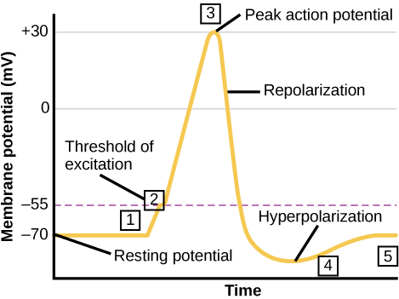The action potential travels down the axon, proceeding as a **wave of depolarization**. The image above shows a trace of an action potential at a single point in the membrane of an axon; the same pattern repeats down the entire length of the axon until it reaches the synapse, shown in te
   * Action potentials always **proceed in one direction only**, from the cell body (soma) to the synapse(s) at the end of the axon. Action potentials **never** go backward, due to the **refractory period** of the voltage-gated ion channels, where the channels cannot re-open for a period of 1-2 milliseconds after they have closed. The refractory period forces the action potential to travel only in one direction.
   * Action potentials **do not vary in** **magnitude or speed**; they are **“all-or-nothing.”**When a given neuron fires, the action potential always depolarizes to the same magnitude and always travels at the same speed along the axon. There is no such thing as a bigger or faster action potential. The parameter that can vary is the **frequency** of action potentials, or how many action potentials occur in a given amount of time.

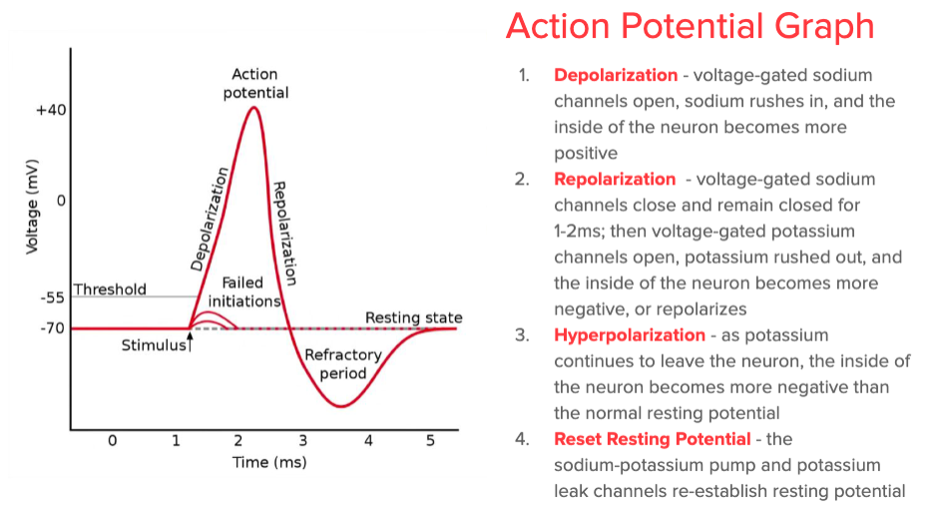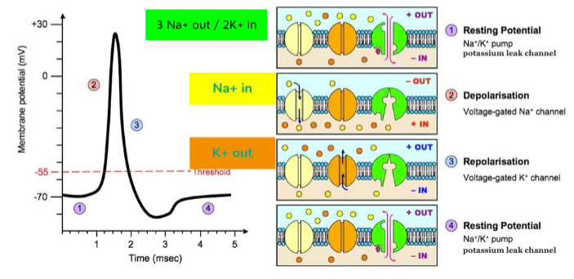

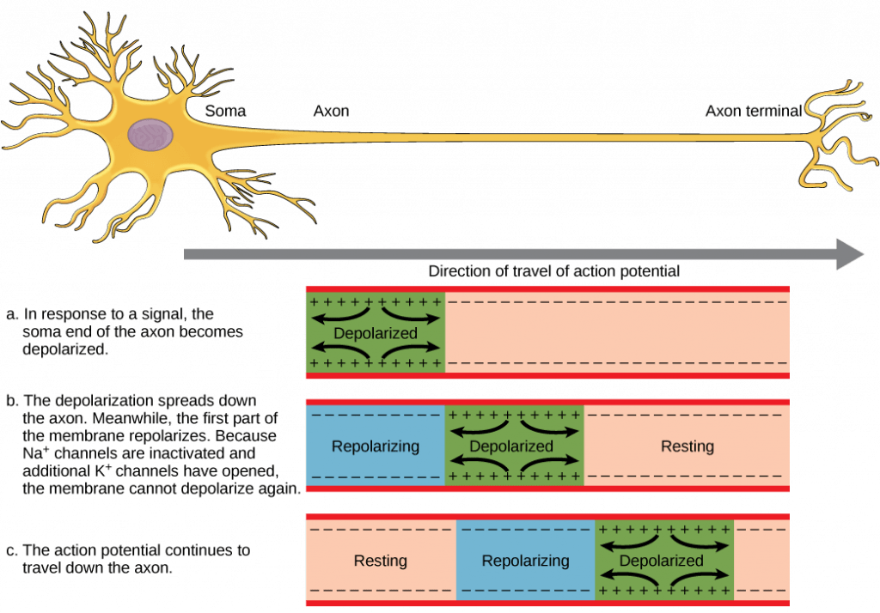

1. Describe the structure and function of neuronal synapses, the process that leads to neurotransmitter release, and the role of neurotransmitters at the synapse
   * Neurons are not in direct physical contact with each other, but instead come into very close proximity at a structure called the **synapse**. The neuron *sending* a signal to the next is called the **presynaptic** neuron, and the neuron *receiving*a signal is called the **postsynaptic** neuron, shown here
   * 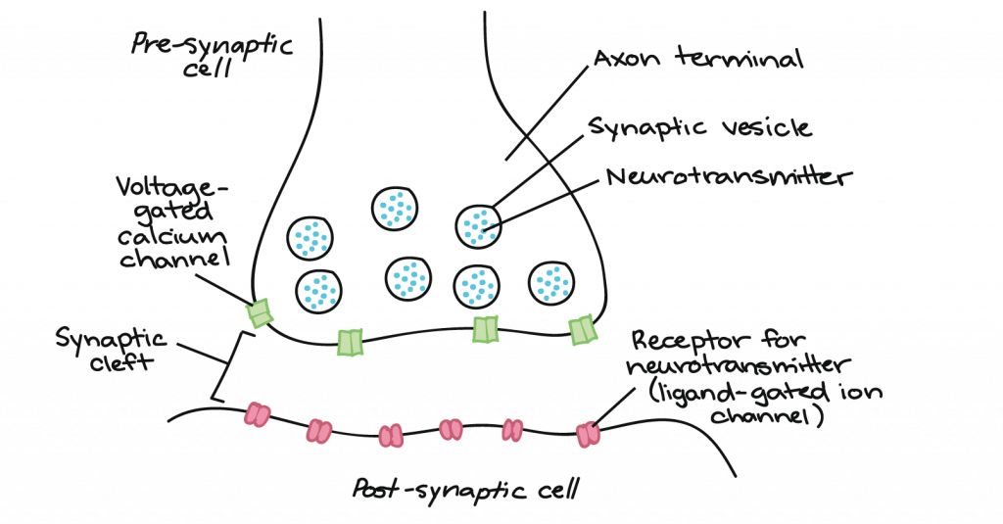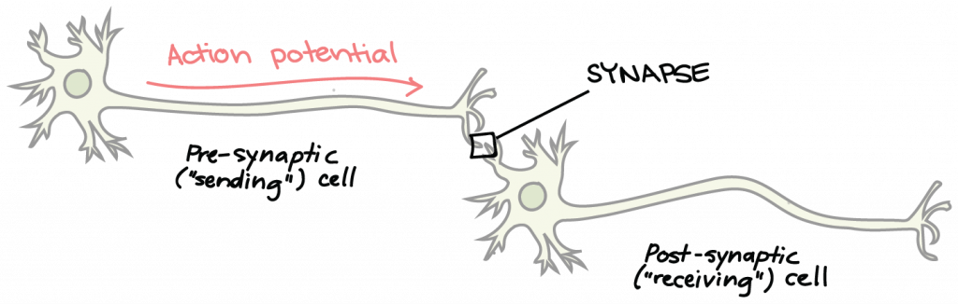There is a small gap between the two neurons called the **synaptic cleft**, where **neurotransmitters**are released by the presynaptic neuron to transmit the signal to the postsynaptic neuron, shown here:
   * How does the synaptic transmission work?
     1. The action potential depolarizes the membrane and opens voltage-gated Na+ channels. Na+ ions enter the cell, further depolarizing the presynaptic membrane.
     2. This depolarization causes **voltage-gated calcium channels**to open in the presynaptic neuron, allowing calcium ions to enter the presynaptic neuron at the synpase.
     3. Calcium ions entering the presynaptic neuron cell initiate a signaling cascade that causes small membrane-bound vesicles, called **synaptic vesicles**, to fuse with the presynaptic membrane. The synaptic vesicles contain neurotransmitter molecules.
     4. 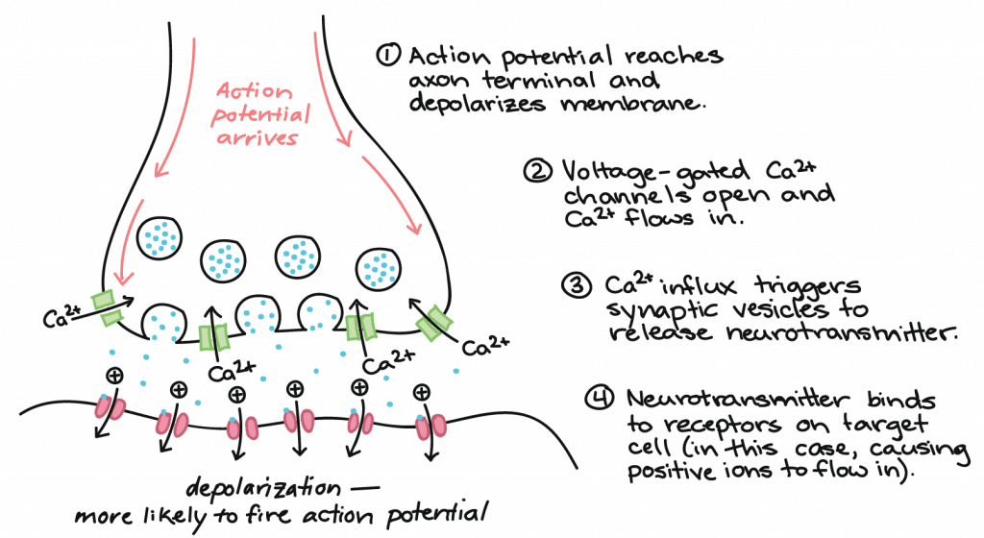Fusion of a vesicle with the presynaptic membrane causes neurotransmitter to be released into the synaptic cleft, the extracellular space between the presynaptic and postsynaptic membranes. The neurotransmitter diffuses across the synaptic cleft and binds to receptor proteins on the postsynaptic membrane.
   * Once neurotransmission has occurred, the neurotransmitter must be removed from the synaptic cleft so the postsynaptic membrane can “reset” and be ready to receive another signal. This can be accomplished in three ways:

* the neurotransmitter can diffuse away from the synaptic cleft
* the neurotransmitter can be degraded by enzymes in the synaptic cleft
* the neurotransmitter can be recycled (sometimes called reuptake) by the presynaptic neuron.

1. Differentiate between excitatory and inhibitory post-synaptic potentials (EPSPs and IPSPs), and predict the results of multiple co-occurring PSPs
   * Excitatory postsynaptic potentials (EPSPs): depolarize the post-synaptic membrane, making the postsynaptic neuron *more*likely to fire an action potential. For example, when acetylcholine is released at the synapse between a nerve and muscle (called the neuromuscular junction) by a presynaptic neuron, it causes postsynaptic Na+ channels to open. Na+ enters the postsynaptic cell and causes the postsynaptic membrane to depolarize.
   * Inhibitory postsynaptic potentials (IPSPs): hyperpolarize the post-synaptic membrane, making the postsynaptic neuron *less* likely to fire an action potential. For example, when the neurotransmitter GABA (gamma-aminobutyric acid) is released from a presynaptic neuron, it binds to and opens Cl– (chloride) channels. Cl– ions enter the cell and hyperpolarizes the membrane.
   * 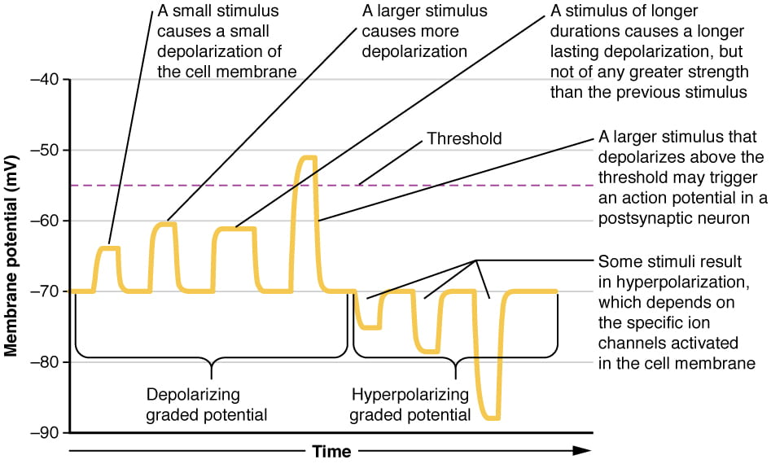While action potentials are “all-or-nothing”, EPSPs and IPSPs are graded, they vary in magnitude of depolarization or hyperpolarization
   * Summation (or integration): A single EPSP typically isn’t strong enough to induce an action potential in the postsynaptic neuron on its own, and multiple presynaptic inputs must create EPSPs around the same time for the postsynaptic neuron to be sufficiently depolarized to fire an action potential

* Occurs at the axon hillock
* in addition, each neuron often has inputs from many presynaptic neuron – some excitatory and some inhibitory – so IPSPs can cancel out EPSPs and vice versa
* It is the net change in postsynaptic membrane voltage that determines whether the postsynaptic cell has reached its threshold of excitation needed to fire an action potential. Together, synaptic summation and the threshold for excitation at the axon hillock act as a filter so that random “noise” in the system is not transmitted as important information.

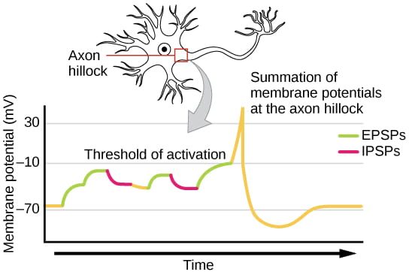

**Nervous Systems**

1. Differentiate between neurons, nerves, and nervous systems
   * Nervous system: organisms control center, a network of neurons which send communications between and across different parts of the body

* Collects and processes sensory information from outside (and inside) the body and controls all behaviors from eating to sleeping to finding a mate
  + Neurons: specialized cells that can receive and transmit chemical or electrical signals (make up the nervous system)
* Structurally supported by glia cells (which provide support functions for the neurons by playing an information processing role that is complementary to neurons)
  + Nerves: bundles of nervous tissue, often containing hundreds to thousands of axons from different neurons wrapped in connective tissue

1. Describe different types of nervous systems in different animal lineages
   * All animals have a true nervous system except sea sponges
   * Cnidarians, such as jellyfish, lack a true brain but have a system of separate but connected neurons called a nerve net.
   * Echinoderms, such as sea stars, have neurons that are bundled into nerves.
   * Flatworms of the phylum Platyhelminthes have both a CNS made up of a small brain and two nerve cords, and PNS containing a system of nerves that extend throughout the body.
   * The insect nervous system is more complex but also fairly decentralized, with a brain, ventral nerve cord, and ganglia (clusters of connected neurons); these ganglia can control movements and behaviors without input from the brain.
   * Cephalopods, such as octopi, may have the most complicated of invertebrate nervous systems, with neurons that are organized in specialized lobes and eyes that are structurally similar to vertebrate species.
   * Compared to invertebrates, vertebrate nervous systems are more complex, centralized, and specialized. While there is great diversity among different vertebrate nervous systems, they all share a basic structure: a CNS that contains a brain and spinal cord and a PNS made up of peripheral sensory and motor nerves.
   * Difference between invertebrates and vertebrates: the nerve cords of invertebrates are located ventrally (along the belly) and the vertebrate spinal cord is located dorsally (along the back)

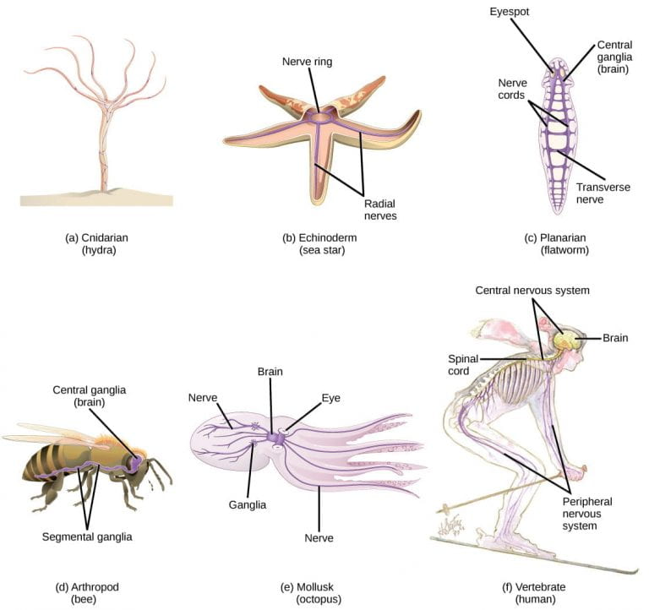

1. Identify, differentiate between, and describe basic structures and functions of the central versus peripheral nervous systems
   * Central nervous system (CNS):

* The brain, which processes information, composed of inter-connected neurons and glial cells
* The spinal cord, which transmits information, consisting of a thick bundle of nerve tissue that carries information about the body to the brain and from the brain to the body
* Interneurons: only in the CNS, which receive information from one set of neurons (usually afferent) and transmit information to another set of neurons (usually efferent)
  + Peripheral nervous system (PNS): collects information and sends commands, containing nerves that extend to and from the spinal cord and are divided into
* Afferent nerves (sensory nerves): which are composed of afferent neurons (sensory neurons) that collect sensory information from the body and transmit it to the CNS
* 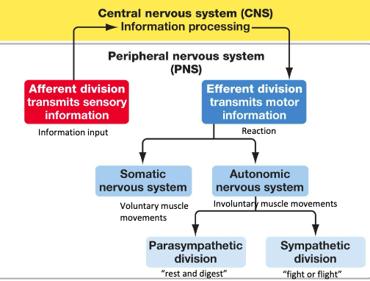Efferent nerves (motor nerves): composed of efferent neurons (motor neurons) that carry commands from the CNS to the body
  + 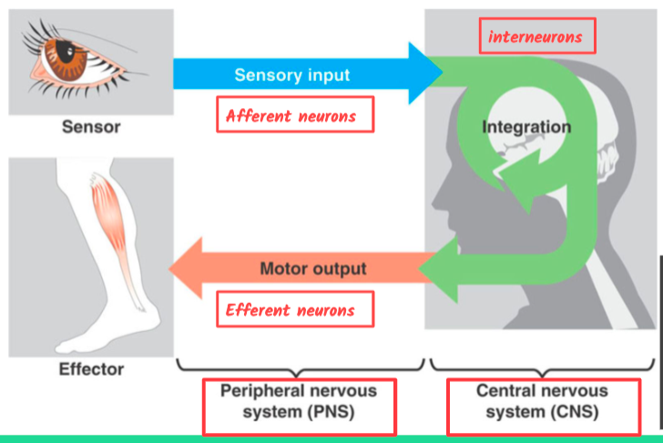Classification of material in the nervous system:
* White matter: myelinated axons
* Gray matter: unmyelinated axons and cell bodies
  + The brain:
* Contained in the skull, floats in a fluid called cerebrospinal fluid (CSF), which is filtered from arterial blood
  + CSF is a cushion and shock absorber and makes the brain neutrally buoyant
  + Glial cells help circulate the CSF to distribute and exchange chemical substances throughout the brain and into the spinal cord
  + Glial cells line fluid filled cavities in the center of the brain called the ventricles (which also contains CSF)
* Brain is organized into white and gray matter:
  + Gray matter: the information processing centers of the brain (outside of the brain-unmyelinated axons and cell bodies)
  + White matter: the networking between the processing centers (inside of the brain-myelinated axons)
* White matter processing centers:
  + Cerebrum and cerebral cortex: make up the majority of the human brain, the outermost part of the cerebrum is called the cerebral cortex, which is folded into hills and valleys
    - Cortex is made up of two hemispheres (left and right) and four lobes (frontal, parietal, temporal, and occipital)
    - Hemispheres are joined together by the corpus callosum, allowing information to be passed from one side to the other
  + Diencephalon: controls homeostasis and acts as a relay station, transmitting sensory information from sensory neurons to the cerebrum (structures in diencephalon are thalamus and hypothalamus)
    - Thalamus:  thalamus acts as a gateway to and from the cortex.; it receives sensory and motor inputs from the body and also receives feedback from the cortex.
    - Hypothalamus: controls the endocrine system by sending signals to the pituitary gland, the “master regulator” of the endocrine system. This relationship means that the hypothalamus regulates important behaviors that are controlled by these hormones. The hypothalamus is effectively the body’s “thermostat” (think *negative feedback loop*); it makes sure key functions like food and water intake, energy expenditure, and body temperature are kept at appropriate levels.
  + Cerebellum (little brain): sits at the base of the brain on top of the brainstem, controls balance and aids in coordinating complex movements and learning new motor tasks
  + Brainstem: connects the rest of the brain with the spinal cord, control functions of the body that do not require conscious thought like alertness, arousal, breathing, blood pressure, digestion, heart rate, swallowing, walking, and sensory and motor information integration
  + Lobes in the hemispheres of the cerebrum:
    - Frontal lobe: located at the front of the brain, contains the olfactory bulb (processes smells) and motor cortex (for planning and implementing movement) and the neurons in the frontal lobe also control cognition functions like maintaining attention, speech, and decision-making, and parts of this area are involved in personality, socialization, and assessing risk
    - Parietal lobe: at the top of the brain, involved in speech and also reading, as well as processing somatosensorial (touch sensations) and processing proprioception (sense of how parts of the body are oriented in space)
    - Occipital lobe: back of the brain, primarily involved in vision (seeing, recognizing, and identifying the visual world), they transmit sensory information from the eyes at the front of the skull to the occipital lobe at the back of the brain
    - 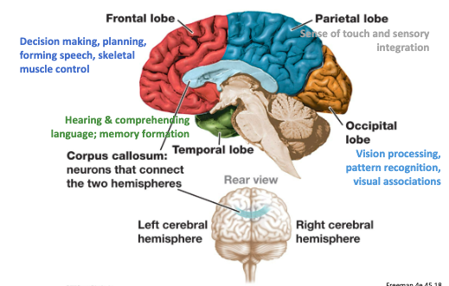Temporal lobe: at the base of the brain by your ears and is primarily involved in processing and interpreting sounds, contains the hippocampus (processes memory formation and is critical for learning)
  + The spinal cord:
* Brain receives information from the environment via the PNS, which relays it to the brain via the spinal cord
* Spinal cord is a thick bundle of nerve tissue that connects to the brainstem and extends down the body through the spinal column
* Spinal cord contained within the bones of the vertebrate column and able to communicate signals to and from the body through its connections with spinal nerves
* Spinal nerves are part of PNS, and spinal column is part of CNS
* Cross section of the spinal cord: a white oval containing a grey butterfly shape
  + Myelinated axons make up the white matter
  + Neuron and glial cell bodies make up the gray matter
* Relay of info to and from the spinal column is directional:
  + Axons and cell bodies in the **dorsal** spinal cord (facing the *back*of the animal) convey mostly **sensory** information from the body to the spinal cord then brain.
  + 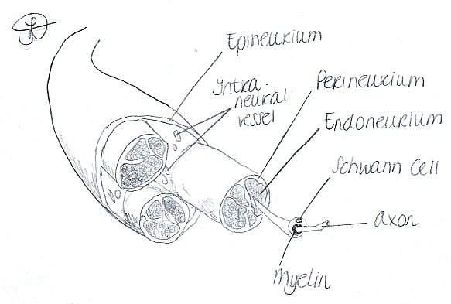Axons and cell bodies in the **ventral** spinal cord (facing the *belly*of the animal) primarily transmit signals **controlling movement** from the brain to out to the body.

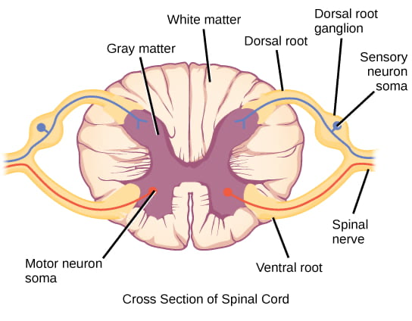

1. Define learning and memory, and explain the roles of the hippocampus, the cerebral cortex, neuroplasticity, and synaptic plasticity in learning and memory
   * Learning: ability to acquire new knowledge
   * Memory: ability to recall it later
   * Both involve specific brain structures as well as certain neuronal processes
   * The current hypothesis states that specific neurons in the cerebral cortex are responsible for physically storing memories, and that learning and memory are mediated by both chemical and structural changes in the synapses of these neurons, or **neural plasticity**: formation of new and loss of existing neural connections.
   * Brain structures involved in learning and memory:

* Prefrontal cortex: short-term memories (part of the frontal lobe)
* Hippocampus in the temporal lobe: essential for consolidating these short term memories into long term memories
* Different components of memories may be stores in different location within the cerebral cortex and that retrieval of long-term memories may involve the prefrontal cortex
  + Chemical and structural changes in synapses involved in learning and memory:
* Neurogenesis: growth of new neurons, which continues into adulthood. About 100 new neurons develop in the hippocampus each day
* Synaptogenesis: growth of new synapses between two existing neurons
* Synaptic pruning: destruction of existing synapses between two neurons
* Synaptic plasticity: strengthening or weakening of existing synaptic connections
  + Long term potentiation (LTP) and long term depression (LTD), important forms of synaptic plasticity that occur in synapses in the hippocampus, brain region that is involved in storing memories
    - Long term potentiation (LTP): the long-term strengthening of a synaptic connection. an increase in the amount of neurotransmitter released by the presynaptic neuron, and an increased response to the same amount of neurotransmitter by the postsynaptic neuron.  LTP can result in **sensitization**, where there is an increased response to the same external stimulus.
    - 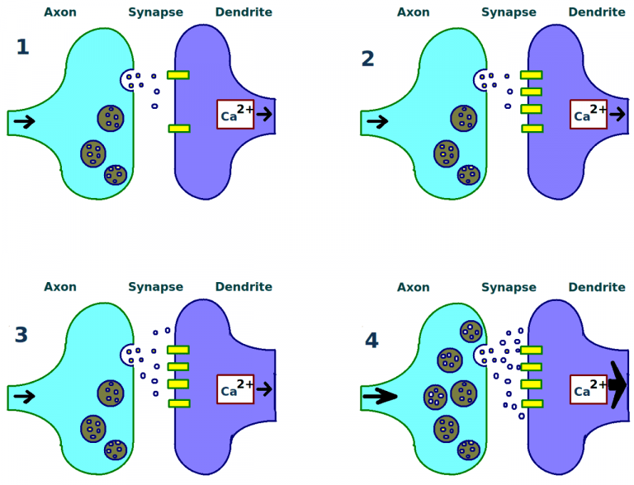Long term depression (LTD): reverse of LTP, long term weakening of synaptic connection. the weakening unused synapses allows for unimportant connections to be lost and makes the synapses that have undergone LTP that much stronger by comparison. LTD can result in **habituation**, where there is a decreased response to the sa me external stimulus.

1. Describe the roles of and differentiate between the divisions of the vertebrate nervous system (afferent, efferent, somatic, autonomic, sympathetic, parasympathetic)
   * PNS is composed of cranial and spinal nerves and can be divided into the different divisions based on structure and function
   * The **afferent (sensory) division:** collects incoming sensory information; made up of cranial and spinal nerves that contain sensory neurons. Sensory neurons transmit sensory information from the skin, skeletal muscle, and sensory organs to the CNS. Without its afferent nervous system, an animal would be unable to receive or process any information about its environment (what it sees, feels, hears, and so on).
   * The **efferent (motor) division:** carries outgoing commands;made up of cranial and spinal nerves that contain motor neurons. Motor neurons transmit messages about desired movement from the CNS to the muscles to make them contract. Motor neurons may be under conscious or unconscious control.  The efferent division can be further divided into:

* The **somatic** (conscious control) **nervous system:** sends motor commands from the CNS to voluntarily-controlled muscles; made up of cranial and spinal nerves that contain motor neurons under conscious control. Without the somatic nervous system, an animal would be unable to respond to its environment via controlled motor movements. Motor neurons of the somatic nervous system synapse with muscles under voluntary control, such as limb muscles.
* The **autonomic** (unconscious control) **nervous system**, which controls bodily functions without conscious control; made of cranial and spinal nerves that contain motor neurons under unconscious control, such as the heart, smooth muscle, and exocrine and endocrine glands. Can be further divided into two systems with opposing effects:
  + The **sympathetic** **nervous system**, which controls the “fight or flight” reactions associated with the short-term stress response. Examples of functions controlled by the sympathetic nervous system include an accelerated heart rate and inhibited digestion. These functions help prepare an organism’s body for the physical strain required to escape a potentially dangerous situation or to fend off a predator. The sympathetic nervous system alters the behavior of may organs directly via synapsed neurons, including the adrenal glands which then release norepinephrine and epinephrine into the blood stream. These hormones then cause further changes, including dilation of the trachea and bronchi (making it easier for the animal to breathe), increasing heart rate, and moving blood from the skin to the heart, muscles, and brain (so the animal can think and run).
  + 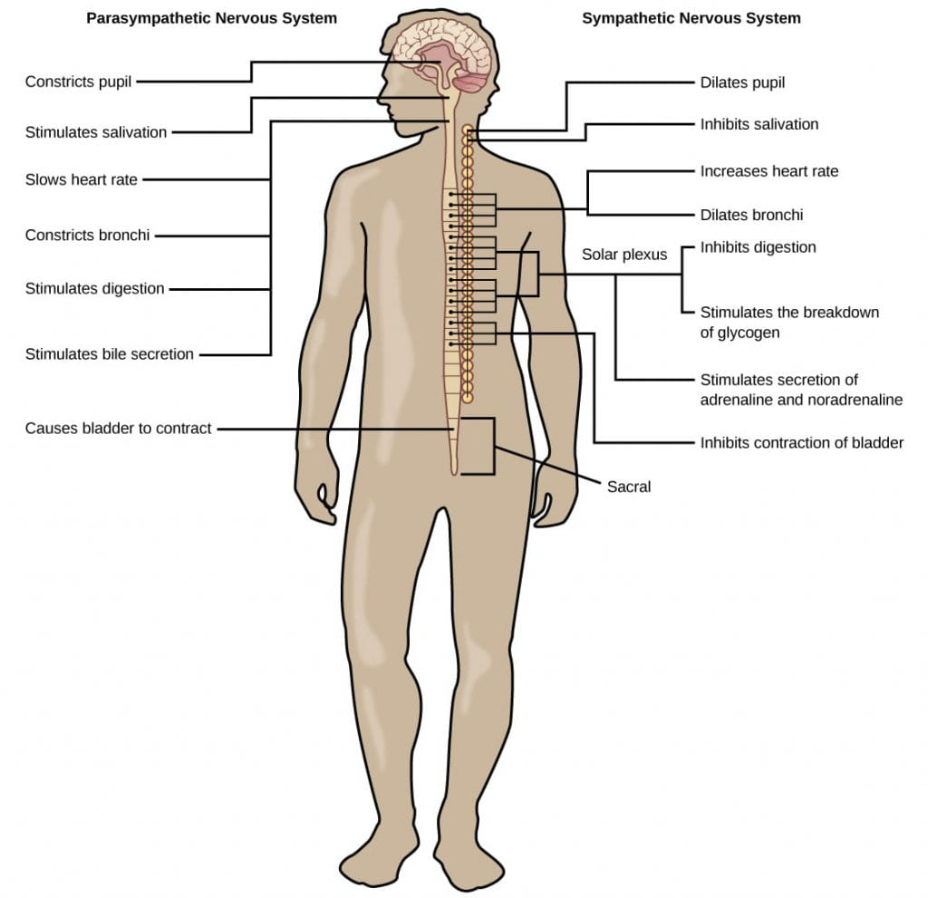The **parasympathetic nervous system:**controls the “rest and digest” activities involved in conserving and restoring energy. The parasympathetic nervous system resets organ function after the sympathetic nervous system is activated (the common adrenaline dump you feel after a “fight-or-flight” event). Effects of the parasympathetic nervous system on target organs include slowing of heart rate, lowered blood pressure, and stimulation of digestion.

1. Recognize the features of a reflex arc, and use reflex arcs as a model to identify the roles of different components of the nervous system
   * Reflexes are quick and unconscious movements
   * Are fast because they involve local synaptic connections in the spinal cord, rather than relay of information to the brain
   * Reflexes usually only involve one or two synapses
   * Synapses with interneurons in the spinal column transmit information to the brain to convey what happened after the event is already over
   * 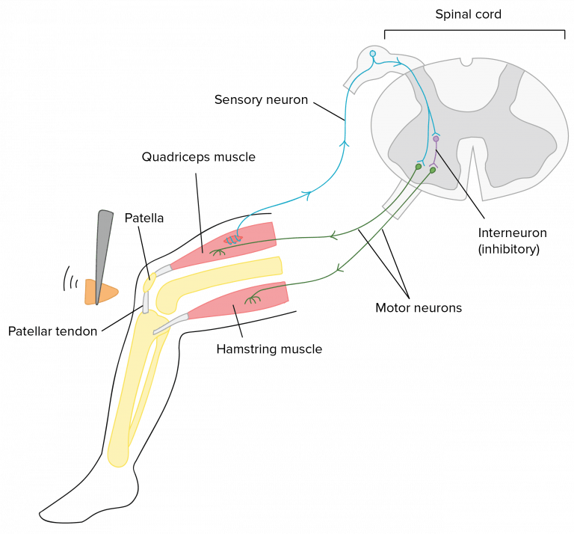The brain is only involved in the learning from the experience

**Animal Sensory Systems**

1. Distinguish between the functions of classes of sensory receptors (mechanoreceptors, chemoreceptors, photoreceptors, nociceptors, thermoreceptors), and identify example animal sensory systems that reply on each type of sensory receptor
   * Sensory receptor cells: transduce external stimuli to changes in membrane potentials

* If the changes in the membrane potential are sufficient to induce an action potential, then these action potentials are communicated along neurons within the afferent division of the PNS to the CNS for information procession.
* The CNS integrates and interprets the incoming signals to effect a response to the appropriate body systems via the efferent division of the PNS
  + Sensory receptor cells are either:
* Specialized neurons, the receptor cell is also a neuron
* Specialized sensory cells which synapse with a neuron (receptor cell secretes neurotransmitters to stimulate changes in membrane potential in the synapsed neuron
  + Sensory receptor cells transduce (convert into changes in membrane potential) and may either depolarize or hyperpolarize in response to the stimulus depending on the sensory system
  + In vertebrates: each sensory system transmits signals to a different specialized portion of the brain such as the olfactory bulb or occipital lobe
* The signal is integrated and interpreted to effect some sort of response (motor output) via the PNS
  + Different sensory receptors are specialized for different types of stimuli:
* Mechanoreceptors: respond to physical deformation of the cell membrane from mechanical energy or pressure
  + Detect touch (somatosensorial)
  + Sound (auditory sensation)
  + Balance (vestibular sensation)
* Photoreceptors: respond to radiant energy
  + Visible light for vertebrates and visible as well as UV in many insects
  + Photoreceptors are present in all types of animal eyes (cup eyes to compound eyes to camera eyes)
* Chemoreceptors: respond to specific molecules dissolved in some medium or airborne
  + Allow animals to taste and smell
* Nociceptors: respond to noxious stimuli or anything that causes tissue damage
  + Perceived tissue damage is interpreted as painful by our brains
* Thermoreceptors: respond to heat or cold

1. Explain the three general mechanisms by which the magnitude or degree of the stimulus (analog data) is accurately communicated via action potentials (digital signals) to the CNS
   * How to detect or perceive the difference between a softer or stronger stimuli (three different ways):

* Rate or frequency of action potentials produced by the sensory receptor
  + an intense stimulus will produce a more rapid series of action potentials, and reducing the stimulus will likewise slow the rate of production of action potentials. (Note the intensity affects the *rate of production of action potentials,*not the speed with which the action potential travels along the axon or the action potential amplitude.)
* Number of receptors activated
  + An intense stimulus might initiate action potentials in a large number of adjacent receptors while a less intense stimulus might stimulate fewer receptors
* Specific receptors are activated
  + A low pitch will initiate action potentials in one set of sensory neurons and a high pitch will initiate action potentials in a different set of sensory neurons

1. Use mechanoreceptors and photoreceptors as model receptor types to describe examples of sensory reception in different animal lineages (eg visual systems, auditory systems, and vestibular sensory systems)
   * Mechanoreceptors (touch, sound, balance)

* Stimuli due to physical deformation of their plasma membranes, are used for sensory systems that detect changes in pressure, ranging from pressure due to touch from a physical object to pressure caused by sound waves
* Mechanoreceptors and the Vertebrate somatosensory system:
  + Touch is detected by a variety of different types of mechanoreceptors that are embedded in the skin, mucous membranes, muscles, joints, internal organs, and cardiovascular system
  + Four primary tactile mechanoreceptors in the skin for each:
    - Some type of mechanoreceptors are located near the upper layers of the skin and are more sensitive to lighter touch and are able to localize gentle touch
    - Other mechanoreceptors are deeper in the skin, and are activated by stronger pressure, are not as highly sensitive
    - 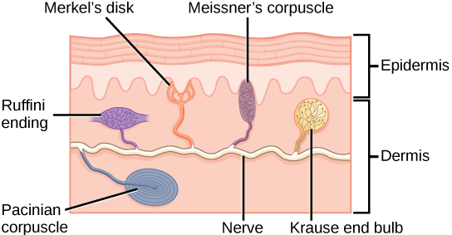A light touch activates only the mechanoreceptors near the upper layer of the skin, while a firmer touch activates mechanoreceptors deeper in the skin, in addition to the mechanoreceptors near the surface of the skin. A firmer touch will also activate a greater number of receptors, and may induce more frequent action potentials in the receptors than a lighter touch
* Mammalian auditory system:
  + Frequency: number of waves per unit of time, heard as pitch
    - Also related to wavelength (high frequency are shorter wavelength and low frequency are higher wavelengths) which is measure in Hz
  + Amplitude: dimension of a wave from peak to trough, heard as volume and measure in dB
  + The outer ear collects sound waves, which travel through the auditory canal and cause the ear drum to vibrate; these vibrations transmit the sound to the middle ear, where three small bones called ossicles, which are unique to the mammalian ear, amplify the vibrations and transmit them to the inner ear; within the inner ear, the vibrations create pressure waves inside the fluid-filled **cochlea**, a “whorled” structure like the shell of a snail, which contains the auditory mechanoreceptors that allow us to perceive pressure waves in the air as sound.
  + In cochlea, basilar membrane is a flexible membrane that runs the length of the cochlea and contains the mechanoreceptors called hair cells which transduce sound waves into action potentials
  + Hair cells have tiny hair like protrusions on their surface called stereocilia
  + When the sound waves in the cochlear fluid contact the basilar membrane, the basilar vibrates in response, pressing the hair cells’ stereocilia against the **tectorial membrane**.
  + When the hair cells is pressed against the tectorial membrane, it physically bends the stereocilia, initiating action potentials in the afferent neurons that communicate sounds stimuli to the brain

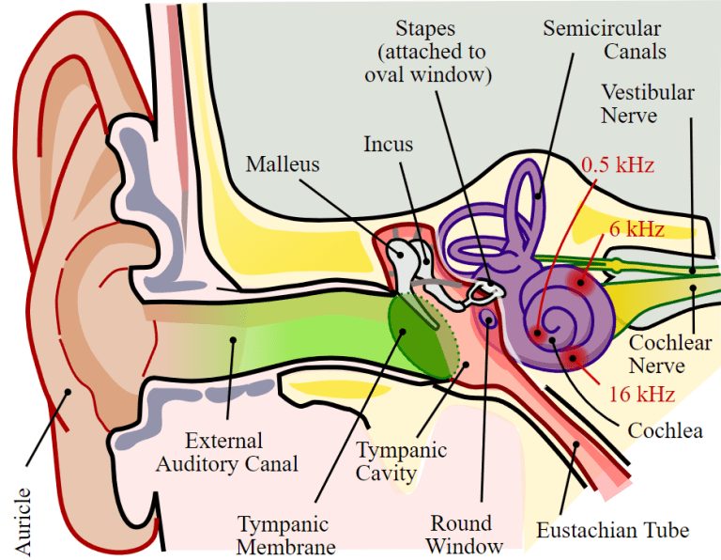

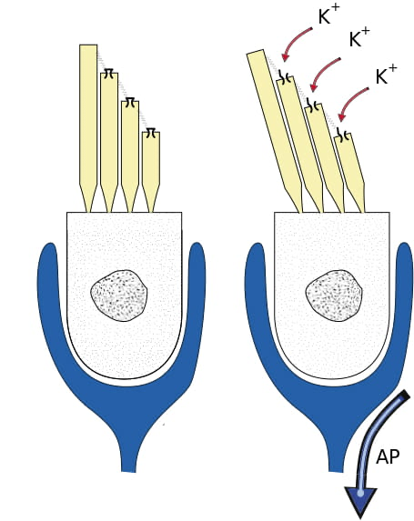

* Volume is based on how many hair cells are activated and sound pitch on which hair cells are activated
* Different hair cells are activated by different pitches of sound because the basilar membranes flexibility changes along its length, thicker, stiffer, and narrower at one end of the cochlea and thinner, floppier, and broader at the other end
* Different regions of the basilar membrane vibrate according to the frequency (pitch) of the sound wave conducted through the fluid in the cochlea
  + Narrow and stiffer region vibrating in response to high frequency (higher pitched) sounds
  + Wider and flexible parts vibrate in response to low frequencies
  + 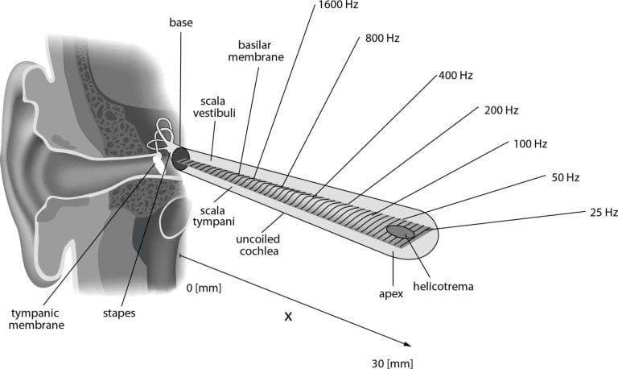Pitch is detected based on which region of the basilar membrane vibrates in response to a sound (which hair cells are activated)
* Vertebrate vestibular system
  + Detect position and movement of our head in space
  + Stimuli associated with vestibular system are linear acceleration (gravity) and angular acceleration and deceleration
  + mechanoreceptor cells in the vestibular system detect gravity based on head position, and changes in acceleration and deceleration in response to turning or tilting of the head.
  + Auditory hair cells are located within the cochlea, and vestibular hair cells are located within the **vestibular labyrinth** which is adjacent to the cochlea.
  + Hair cells in the vestibular labyrinth detect stimuli in two ways:
    - 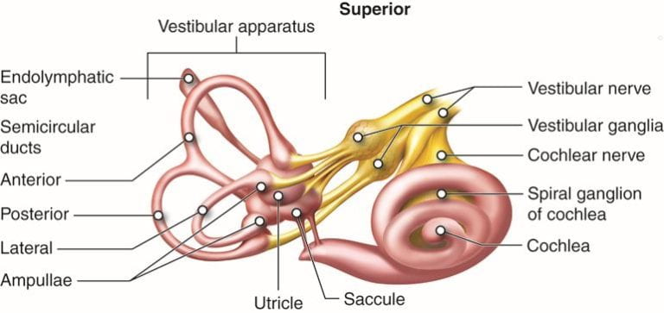Some hair cells lie below a gelatinous layer with their stereocilia projecting into the gelatin
    - Embedded in this gelatin are calcium carbonate crystals**,**like tiny rocks, that move in response to gravity. Any time the head is tilted at an angle or is subject to acceleration or deceleration, these crystals cause the gelatin to shift, bending the stereocilia. The bending of the stereocilia stimulates the neurons, and they signal to the brain that the head is tilted, allowing the maintenance of balance.

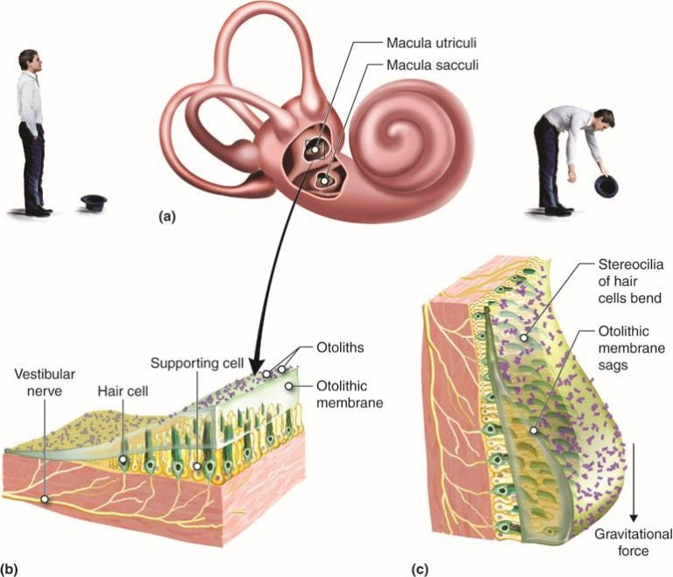

* Some hair cells project into a gelatinous cap called the cupula
* 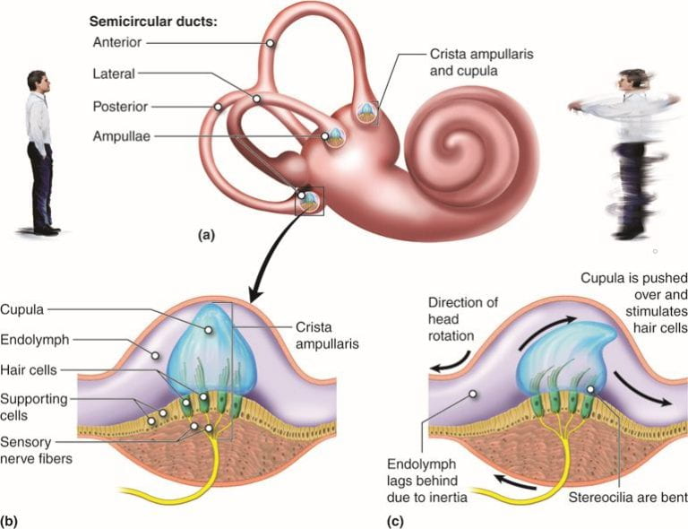When the head turns, the fluid in the canals shifts, bending stereocilia and sending signals to the brain, when movement stops, the movement of the fluid within the canals slows or stops
  + 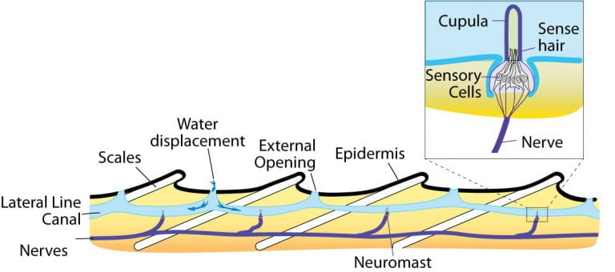Vestibular system in bony fish: a system involving hair cells and a cupula is present at the lateral line of bony fish (used to detect changes in water pressure)
  + In invertebrate: detect balance through a structure called a statocyst (ball shaped organ with inward facing hair cells and containing statoliths (dense particles similar to calcium carbonate crystals in the vertebrate vestibular labyrinth))
    - 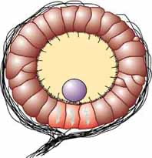Movement causes the statoliths to change location inside the statocyst which activates different hair cells
  + Photoreceptors for vision
* The behavior of light can be discussed in terms of the behavior of waves and also in terms of the behavior of the fundamental unit of light: a packet of electromagnetic radiation called a photon. Humans can perceive just a small slice of the entire electromagnetic spectrum, which includes radiation that we cannot see as light because it is below the frequency of visible red light and above the frequency of visible violet light, which are the limits of vertebrate light detection.
* Wavelength: varies inversely from frequency is detected as hue or color red end of the visible spectrum has longer wavelengths and the violet end has shorter wavelengths (higher frequency)
* Wave amplitude is perceived as luminous intensity or brightness
* Detection of light is through photoreceptors (located in light collecting organs called eyes)
* Different structures of light:
  + Eye cups: flatworms, dimple shaped structures that detect the direction of a light source
  + Compound eyes: arthropods, contain multiple lenses and detect shapes, patterns, and movements
  + Pinhole eyes: nautilus, contain no lens and forms simple, low-resolution images
  + Simple eyes: cephalopods and vertebrates, contain a single lens and form high-resolution images

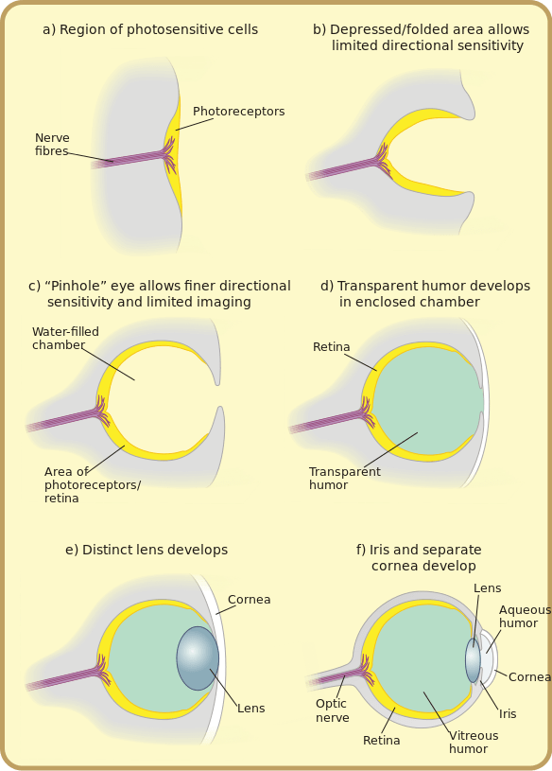

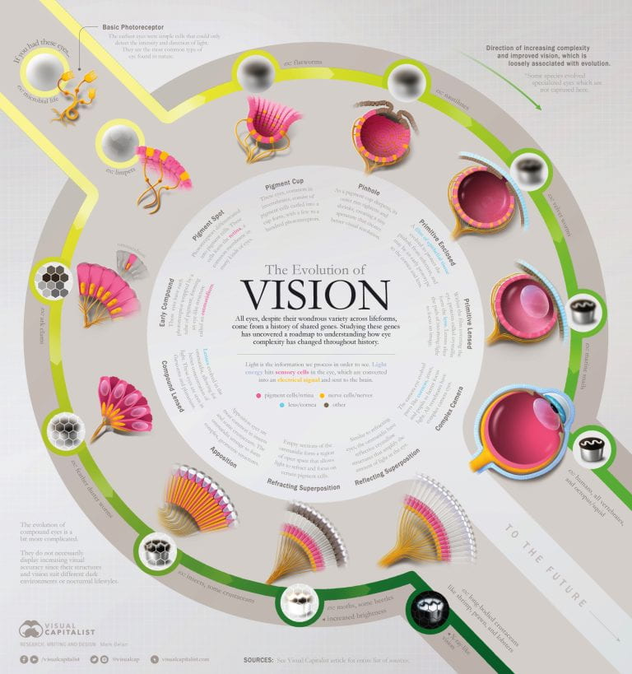

* Structure of vertebrate eye:
  + Cornea: transparent sheet of connective tissue, functions with the lens to focus light on the retina
  + Iris: pigmented ring of muscle that controls amount of light entering eye
  + Pupil: hole in center of iris
  + Lens: crystalline, curved structure that focuses light on the cornea (by bending not by moving) in conjunction with the cornea
  + Retina: thin layer of photoreceptor cells and neurons
    - Photoreceptor cells: light detecting sensory cells
    - Fovea: site of retina with only cones, area of highest visual resolution
  + Optic nerve: axons of the ganglion cells
* Vertebrate vs cephalopod eyes:
  + Cephalopod eyes *move the lens* to focus (like in a camera), rather than *changing lens shape*as in the vertebrate eye; the result in vertebrates is age-related loss of resolution as the lens loses flexibility over time
  + 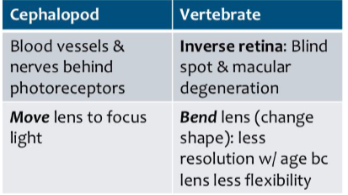Vertebrate eyes have an “inverted” retina, where blood vessels and nerves are *in front*of the photoreceptor cells, unlike in the cephalopod eye where the nerves are *behind* the photoreceptor cells; the result in vertebrates is the blind spot as well age-related macular degeneration and increased likelihood of retina detachment (a severe medical emergency) due to the loose association between the retina and the back of the eye
* All photoreceptors rely on a light-absorbing pigment molecules embedded in the photoreceptor cells
  + Pigment is called retinal and is contained in a protein called opsin
  + This forms a complex called rhodopsin, which allows us to detect light and color
  + Retinal (the pigment) reversible changes shape when it is hit by a photon of light
  + Opsin (the protein) holds the retinal pigment and changes shape/acitivity when the retinal changes shape in response ot absorption of light
    - Responsible for being able to perceive hues
    - Three are: S opsin (short wavelength), M opsin (medium wavelength), and L opsin (long wavelength)
  + Photoreceptor cells contain rods and cones that each contain unique opsin that causes the cell to be most sensitive to a specific wavelength of light
    - Cones (cone shaped): each contain a single type of color sensitive opsin, so each cone becomes most sensitive to a particular hue or color of light
      * Variation of hues: activation of different combination of cones at the same time
      * Cones require light so we cant see color well in the dark
      * Cones are concentrated at the fovea
      * Useful for important visual details
    - Rods (rod shaped): each contain a fourth type of opsin called rod opsin
      * Activated by intermediate wavelength of light
      * Not color sensitive
      * Capable of working in low levels of lights (why we cannot perceive color well in dim light)
      * Heavily concentrated at the periphery (outer edges) of the retina, and useful for detecting movement in our field of vision
    - A rod or cone cell hyperpolarizes when its rhodopsin’s are activated by light and depolarizes when its rhodopsin’s are in the dark
      * When in the dark our rods and cones are depolarized and thus releasing neurotransmitters to their synapsed bipolar cells
      * When activated by light, it hyperpolarizes and stops releasing neurotransmitter

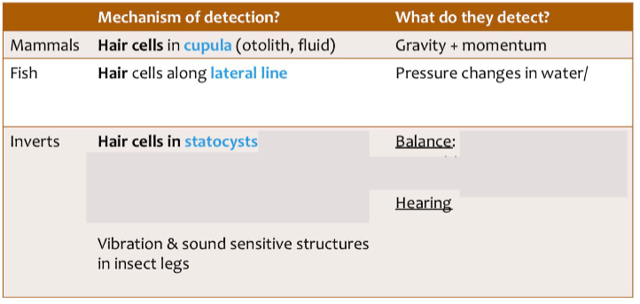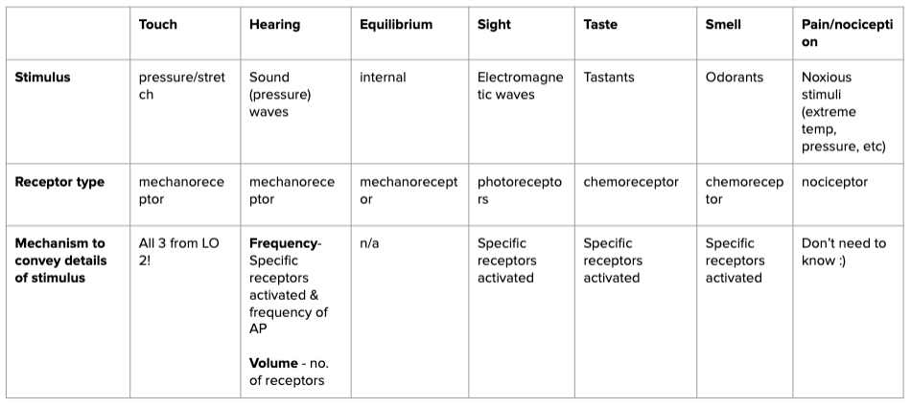

**Motor proteins and muscles**

1. Explain the roles of ATP, cytoskeletal proteins, and motor proteins in cilia, flagella, and muscle in controlling cell and organism movement
   * Structures for movement in both single celled and multicellular animals rely on moto proteins and components of the cytoskeleton
   * Cytoskeleton: a network of filaments that supports the plasma membrane, gives the cell an overall shape, aids in the correct positioning of organelles, provide tracks for the transport of vesicles, and allows the cell to move

* Three types of protein fibers in the cytoskeleton: microfilaments, intermediate filaments, and microtubules
* Cytoskeleton serve as tracks for movement of motor proteins, which use energy in the form of ATP to walk along these cytoskeletal filaments (not intermediate filaments)
* Microfilaments (actin filaments): composed of actin protein subunits and serve as tracks for the motor protein myosin and are involved in many cellular processes that require motion. In muscle cells, they form organized structures of overlapping filaments called sarcomeres. When actin and myosin filaments of a sarcomere slide past each other, the muscle contracts
* Microtubules: made up of tubulin proteins and serve as tracks for the motor proteins kinesin and dynein. Play a role in cellular structural integrity and cell movement (via cilia and flagella)
  + Motor proteins use energy in the form of ATP to walk along specific cytoskeletal tracks
* Essential for the movement of vesicles and other cargoes within cells
* Essential for movement of muscle and cilia and flagella
* Myosin is associated with actin microfilaments and is required for movement of muscle
* Dynein is associated with tubulin microtubules and is required of movement of cilia and flagella
* Kinesin is associated with tubulin microtubules and is required for movement of vesicles and other intracellular cargoes
  + Flagella and cilia
* ATP, dynein motor proteins and microtubules are essential for movement of eukaryotic cilia and flagella
* Flagella: long hair like structures that extend from the cell surface and are used to move an entire cell, usually one or just a few in one cell
* Cilia: shorter that flagella and appear in large numbers on the cell surface. When cells with motile cilia form tissues, the beating helps move materials across the surface of the tissue
* Common structural pattern in motile cilia and flagella:
  + have 9 pairs of microtubules arranged in a circle with 2 microtubules in the center of the ring (9 + 2) array
  + Individual pairs of microtubules are physically connected to each other via protein bridges, physically anchored to the base of the cilium or flagellum
  + Pairs of microtubules are physically connected via motor protein called dynein’s that move along the microtubules, generating a force that causes the flagellum or cilium to beat. Dynein is anchored to one doublet and walks along the adjacent doublet. Synchronous movement of all dynein molecules across the entire structure causes the cilium or flagellum to bend
  + 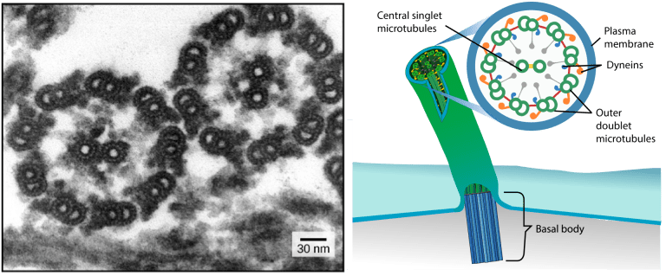The structural connections between the microtubule pairs and the coordination of dynein movement allow the activity of the motors to produce a pattern of regular beating, driving the cell to move in a coordinated fashion.

1. Differentiate between the different types of muscle (skeletal, smooth, and cardiac)
   * Three types of muscle tissue: skeletal muscle, cardiac muscle, and smooth muscle
   * Skeletal muscle:  muscles attach to bones or skin and control locomotion and any movement that can be *consciously*controlled; skeletal muscle is also called *voluntary*muscle. Skeletal muscles are long and cylindrical in appearance; when viewed under a microscope, skeletal muscle tissue has a striped or striated appearance. The striations are caused by the regular arrangement of contractile proteins (actin and myosin – more on this below).
   * Smooth muscle: muscle tissue occurs in the walls of hollow organs such as the intestines, stomach, and urinary bladder, and around passages such as the respiratory tract and blood vessels. Smooth muscle has no striations, is under autonomic control; smooth muscle is also called *involuntary* muscle.
   * Cardiac muscle: muscle tissue is only found in the heart, and cardiac contractions pump blood throughout the body and maintain blood pressure. Like skeletal muscle, cardiac muscle is striated, but unlike skeletal muscle, cardiac muscle cannot be consciously controlled and is another category of involuntary muscle.

* The nervous system can speed up or slow down the heart rate, but the heart can also beat without nervous system input due to a set of cells called **pacemaker cells** that spontaneously initiate cardiac muscle contraction.
* 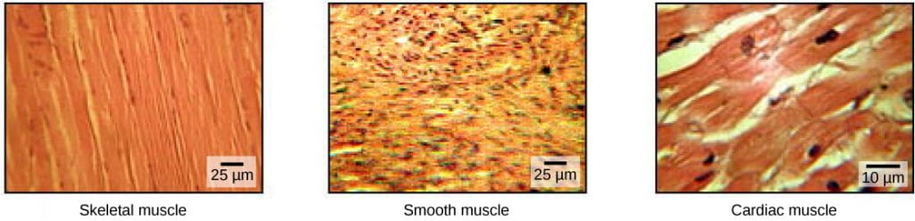Cardiac muscle has **intercalated disks**, which enable rapid passage of action potentials from one cardiac muscle cell to the next

1. Describe the structure of skeletal muscle, and explain the role of this structure in muscle contraction and regulation of muscle contraction through the sliding filament model
   * Muscles are composed of structures that enable contraction to promote organismal movement
   * Each skeletal muscle cell is called a muscle fiber

* Within each muscle fiber there are myofibrils, long cylindrical structures that lie parallel to the muscle fiber, which run the entire length of the muscle fiber
* Each myofibril contains repeating units called sarcomeres, the action functional units that cause contraction of a muscle (“the contractile units”)
  + 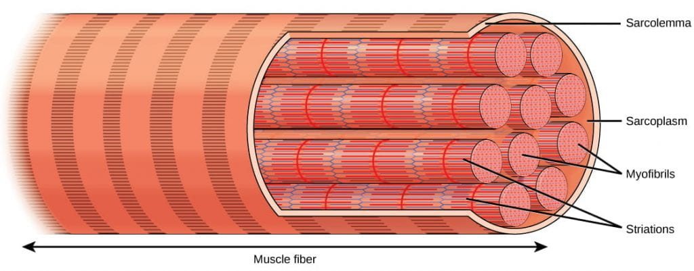Give muscle its striated or branded appearance due to the alternating bands of actin and myosin that allow sarcomeres to contract
  + Each sarcomere contains a thick filament of myosin and a thin filament of actin
    - Actin filaments are physically anchored to structures at the end of each sarcomere, called Z discs or Z lines
    - The center of the myosin filament is marked by a structure called the M line
    - One sarcomere is the space between two consecutive Z discs
    - A myofibril is composed of many sarcomeres running along its length and as the sarcomeres individually contract, the myofibrils and muscle cells shorten

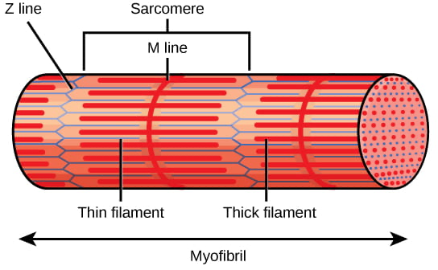

* Protein components of the sarcomere (myosin, actin, tropomyosin, troponin):
  + Myosin: thick filaments are composed of myosin. The tail of a myosin molecule connects with other myosin molecules to form the central region of a thick filament near the M line, whereas the heads align on either side of the thick filament where the thin filaments overlap.
  + Actin: The primary component of thin filaments is the actin protein. Actin filaments are attached at the Z disc and extend toward the M line, overlapping with the myosin heads of the thick filament
  + Tropomyosin: Actin has binding sites for myosin attachment, but strands of tropomyosin block the binding sites and prevent actin-myosin interactions when the muscles are at rest.
  + Troponin: Tropomyosin is regulated by troponin, which is regulated by calcium (Ca2+) ions. The binding of Ca2+to troponin causes the troponin-tropomyosin complex to move away from the myosin binding sites on the actin filament, allowing myosin to bind to actin to initiate muscle contraction (more on this later in this reading)
  + Slide filament model: during muscle cell contraction, the sarcomere has to shorten but thick and thin filaments (myosin and actin) do not shorten. Myosin and actin will slide past each other causing the sarcomere to shorten while the filaments remain the same length
  + Mechanism of contraction is the binding of myosin to actin, forming cross-bridges that generate filament movement
  + 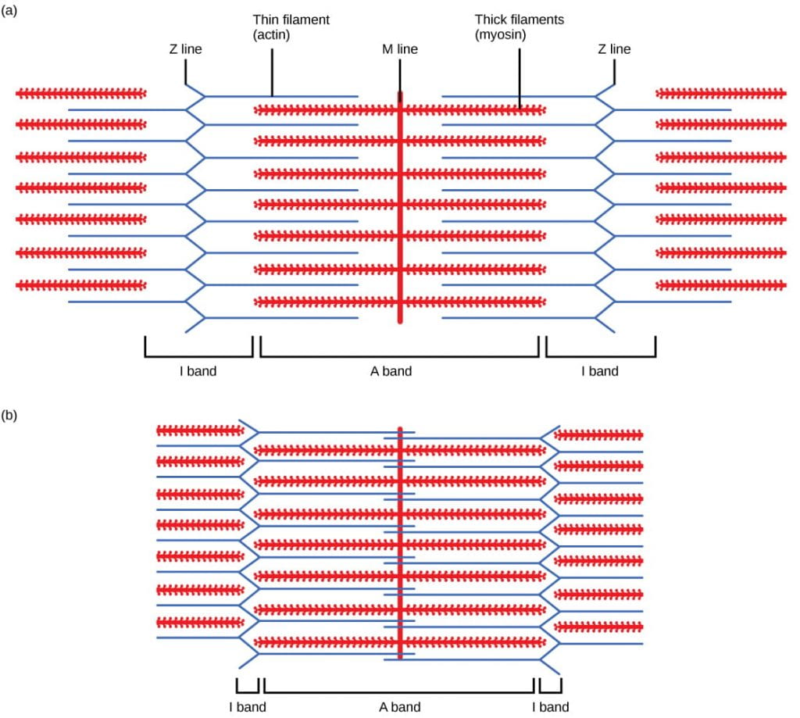Sliding filament model is accomplished by the cross bridge cycle
  + When a sarcomere shortens, the distance between the Z discs is reduced even though the filaments within the sarcomere stay the same length. This is because thin filaments are pulled by the thick filaments toward the center of the sarcomere until the Z discs approach the thick filaments. The filaments appear to *slide* past each other as illustrated below:

1. Explain the steps and process of the cross-bridge cycle in muscle contraction
   * Cross bridge cycle:

* At the start of a cycle, myosin binds to ATP, but it is not yet bound to actin.
* Myosin then hydrolyzes ATP into ADP and inorganic phosphate, and the myosin remains bound to both of these molecules. In this state, it can then attach to a myosin-binding site on the actin thin filament if the binding sites are available (if not, the myosin will remain in this state until the binding sites become available).
* After binding to actin, the myosin protein releases the inorganic phosphate (but stays bound to ADP); the release of inorganic phosphate causes the myosin head to ratchet in what is called “**the powerstroke**,”pulling the actin thin filament toward the M line and causing muscle contraction.
* 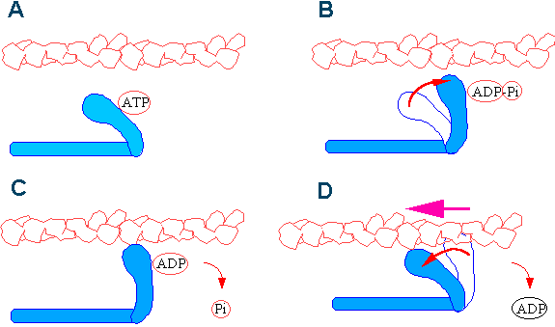After the power stroke is completed, the myosin protein releases ADP.  In this state, it remains stuck to the actin filament until it binds another ATP molecule. Because ATP is required for myosin to be able to release the actin, depletion of ATP due to muscle fatigue will cause muscles to remain locked in a contracted state; this is thought to be one of several sources of cramping after exercise.

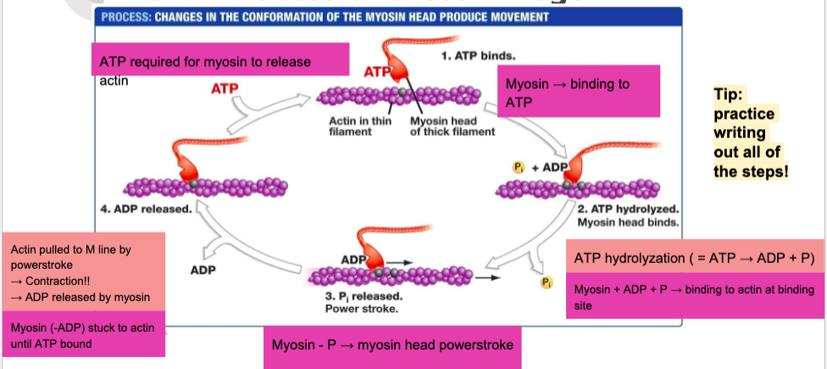

1. Describe the structure and function of the neuromuscular junction, and explain the process by which the nervous system and the sarcoplasmic reticulum regulate muscle contraction through availability of calcium
   * Regulation of muscle contraction is accomplished via troponin-tropomyosin complex and the nervous system
   * Troponin and tropomyosin determine whether myosin can bind to actin or not

* **Tropomyosin blocks myosin from binding to actin:**When a muscle is in a resting state, actin and myosin are separated. To keep myosin from binding to the actin, tropomyosin covers over (blocks) the myosin binding sites on actin molecules, preventing cross-bridge formation and preventing contraction in a muscle without nervous input.
* Tropomyosin is regulated by troponin, and troponin is regulated by calcium: To enable a muscle contraction, tropomyosin must change conformation and uncover the myosin-binding site on an actin molecule and allowing cross-bridge formation.
  + Tropomyosin only moves away from actin in the presence of calcium, which is kept at extremely low concentrations in the sarcoplasm (muscle cell cytoplasm). If present, calcium ions bind to troponin, causing conformational changes in troponin that allow tropomyosin to move away from the myosin binding sites on actin.
  + Once the tropomyosin is removed, a cross-bridge can form between actin and myosin, triggering contraction. Cross-bridge cycling continues until Ca2+ ions and ATP are no longer available, and tropomyosin again covers the binding sites on actin.
* Availability of calcium is regulated by the nervous system, as calcium is stored in the endoplasmic reticulum, called sarcoplasmic reticulum (SR) in muscle cells. The efferent neurons which control a muscle are synapsed with the muscle in a structure called the neuromuscular junction (neuromuscular synapse)
  + When an action potential propagates down the axon of the efferent neuron, the neurotransmitter **acetylcholine** (ACh) is released by the neuron into the synaptic cleft of the neuromuscular junction.
  + ACh binds to ACh receptors on the muscle cell, which depolarizes the muscle cell and initiates an action potential in the muscle using exactly the same biochemistry as an action potential in a neuron (influx of sodium ions, efflux of potassium ions)
  + The depolarization of the muscle cell then spreads through structures called **T-tubules**, which carry the action potential into the **sarcoplasmic reticulum**(SR).
  + Depolarization of the SR causes the SR to release calcium into the muscle cytoplasm.
  + The sudden presence of calcium in the cytoplasm causes the tropoin-tropomyosin complex to move away from blocking the myosin binding sites on the actin thin filament, allowing muscle contraction to occur.
  + 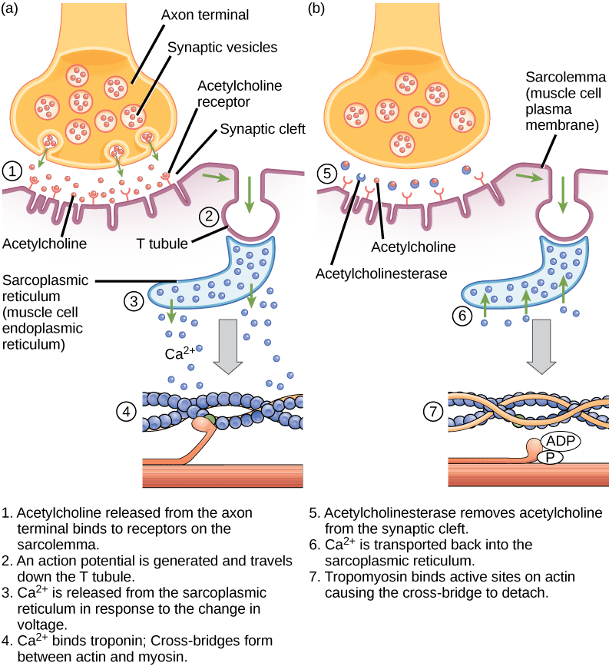After the end of the action potential, the muscle cell returns to its membrane resting potential and calcium is rapidly pumped back into the SR, ending muscle contraction and allowing the muscle to relax (as long as ATP is present to cause myosin to release the actin).

**Motor units and skeletal system**

1. Define muscle ‘twitch’ and muscle tetanus
   * Skeletal muscle contractions occurs when the cross bridge cycle of actin myosin binding is activated which happens when the muscle cell receives action potentials from an efferent neuron
   * When the muscle contracts, it pulls on connective tissue which connects the muscle to bones, which results in a skeletal movement
   * Twitch: one unit of muscle contraction, caused by each action potential
   * Tension: or pull exerted by the muscle as a result of a twitch
   * Muscle contractions are graded
   * Maximum possible tension possible for a given muscle is called tetanus
2. Define motor units and explain how the nervous system regulates graded muscle contractions (muscle tension)
   * Amount of tension produced in a muscle contraction depends on two factors: the number of muscle fibers activated, the frequency of neural stimulation to the muscle fibers

* Number of muscle fibers activated: activating varying numbers of motor units, A single efferent neuron will typically control multiple muscle fibers, and there are many many neurons that control different muscle fibers in a single muscle. A single efferent neuron all of the muscle fibers that it controls is called a **motor unit**. The more motor units are active, the greater the number of muscle fibers that contract, and the greater the degree of muscle contraction.
* Frequency of neural stimulation: action potential cant vary in magnitude or speed but the frequency of action potentials can vary. One unit of muscle contraction (or a twitch) can be additive, if the action potentials are rapid enough (and the muscle is not allowed to relax in between action potentials) the muscle will continue to contract to a greater and greater degree with each new action potential

1. Define and explain the physiological differences between fast-, slow-, and intermediate-twitch muscle fibers
   * All muscle fibers require ATP for the cross-bridge cycle to occur, and depletion of ATP causes muscle fatigue (exhaustion). Different types of skeletal muscle fibers fatigue at different rates due to (among other things) different sources of ATP:

* **Oxidative**muscle fibers rely on [**oxidative phosphorylation**](http://bioprinciples.biosci.gatech.edu/module-3-molecules-membranes-and-metabolism/05-respiration-chemiosmosis-and-oxidative-phosphorylation-2/) to generate ATP. Since oxidative phosphorylation occurs in mitochondria and requires oxygen, oxidative muscles tend to:
  + have high concentrations of mitochondria
  + appear to be deep red due to high concentrations of **myoglobin**, which delivers oxygen to the mitochondria from the bloodstream.
  + be slow to fatigue (become exhausted): oxidative phosphorylation is comparatively slow for producing ATP, but it is also relatively inexhaustible; it generally takes a very long time to run out of ATP in oxidative muscles.
* **Glycolytic** muscle fibers rely on glycolysis to generate ATP. Since glycolysis occurs in the cytoplasm and does not require mitochondria (and thus do not require oxygen for contraction), glycolytic muscles tend to:
  + have low densities of mitochondria
  + appear white due to the comparatively lower concentration of myoglobin
  + be quick to fatigue: glycolysis is comparatively fast for producing ATP, but it is also a rapidly-exhausted source of ATP; glycolytic muscles typically run out of ATP very quickly.
* These properties impact the rate of twitch and the rate of ATP depletion in a muscle type
  + **Fast-twitch**muscles provide brief, rapid, and powerful contractions; they are adapted for bursts of activity and tend to be present in muscles required for short-lived activities such as running. They tend to:
    - be composed of **glycolytic** muscle fibers
    - contain fewer mitochondria
    - appear white due to lower concentrations of myoglobin
    - be very quick to fatigue.
  + **Slow-twitch** muscles are capable of maintaining long contractions but are slower to contract. Slow-twitch oxidative muscles are adapted for endurance activities, and tend to be present in muscles required for long-lived activities such as supporting the body core. They tend to:
    - be composed of **oxidative** muscle fibers
    - contain many more mitochondria
    - appear red due to higher concentrations of myoglobin
    - be very slow to fatigue.

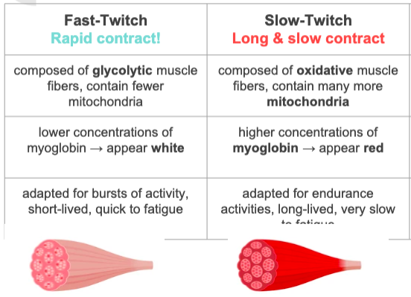

1. Compare and contrast hydrostatic skeletons, exoskeletons, and endoskeletons
   * Muscles need to interact with a skeletal system, which is necessary to support the body, protect internal organs, and allow for the movement of an organism
   * Muscles function in antagonistic pairs:

* Functioning on its own, a muscle can only contract (pull); *there is no mechanism within a muscle to cause it to extend (push)*.
* Extension of a muscle therefore is accomplished by the contraction of an *antagonistic* muscle, or a muscle that pulls in the opposite direction.
* In our own skeletons, you can visualize this from the muscles of the arm: contracting the bicep pulls your forearm toward your shoulder; contracting the tricep pulls your forearm back down to your side. In hinge-based skeletal systems (endoskeletons and exoskeletons), opposing muscles are called **flexors** or **extensors**. Flexors (like the bicep) pull two bones toward each other; extensors (like the tricep) straighten two bones out.
  + Different type of skeletal systems:
* A **hydrostatic skeleton**is a skeleton formed by a closed, fluid-filled compartment within the body, called the **coelom**.
  + The organs of the coelom are supported by the aqueous fluid, which also resists external compression. This compartment is under hydrostatic pressure because of the fluid and supports the other organs of the organism.
  + This type of skeletal system is found in soft-bodied animals such as sea anemones, earthworms, Cnidaria, and other invertebrates. Although a hydrostatic skeleton is well-suited to invertebrate organisms such as earthworms and some aquatic organisms, it is not an efficient skeleton for large terrestrial animals.
  + Movement in a hydrostatic skeleton is provided by muscles that surround the coelom. The muscles in a hydrostatic skeleton contract to change the shape of the coelom; the pressure of the fluid in the coelom produces movement.
  + As in other skeletal systems, the *muscles are always paired*. For example, earthworms move by waves of muscular contractions in the called peristalsis, which alternately shorten and lengthen the body. Lengthening the body by contracting the longitudinal muscles causes the anterior end of the organism to extend. Shortening the body by contracting the opposing circular muscles then draws the posterior portion of the body forward, resulting in forward movement.
  + Hydrostatic skeletons place no constraints on the contraction width of the muscle, as there is no hard physical barrier that limits the size of the muscle.
* Exoskeleton:  an external skeleton that consists of a hard encasement on the surface of an organism.
  + Exoskeletons provides defense against predators, support the body, and allows for movement through the contraction of attached, opposing muscles.
  + Exoskeletons are present in arthropods and mollusks. Arthropods such as crabs and lobsters have exoskeletons that consist of 30-50 percent chitin, a polysaccharide derivative of glucose that is a strong but flexible material. The exoskeleton is further strengthened by the addition of calcium carbonate in organisms such as the lobster.
  + Because the exoskeleton is not composed of cells and cannot grow larger, arthropods must periodically shed their exoskeletons (and form a new one) as their bodies grow larger.
  + Unlike in a hydrostatic skeleton, muscles must cross a joint inside the exoskeleton to effect movement. Shortening of the muscle changes the relationship of the two segments of the exoskeleton, drawing the segments together (flexion) or moving them apart (extension).
  + Another difference from the hydrostatic skeleton is that an exoskeleton physically constrains the contraction size of a muscle; the muscle can only increase in diameter so much before it physically runs out of room due to the hard shell of the exoskeleton.
* Endoskeleton: a skeleton that consists of hard, mineralized structures located within the soft tissue of organisms.
  + Endoskeletons are present in sponges (yes, sponges!), echinoderms, and chordates. Mammalian skeletons have on the order of over 200 bones, including some that are fused and some that are connected by ligaments at joints to allow movement.
  + The skeletal system in vertebrates is divided into the axial skeleton (which consists of the skull, vertebral column, and rib cage), and the appendicular skeleton (which consists of the shoulders, limb bones, the pectoral girdle, and the pelvic girdle).
  + Like the exoskeleton (and unlike the hydrostatic skeleton), endoskeletons are jointed and have opposing flexor and extensor muscles.
  + But like the hydrostatic skeleton (and unlike the exoskeleton), endoskeletons do not constrain the diameter of a muscle during contraction (if it did, bodybuilding couldn’t be a thing.)